INTRODUCTION
CHAPTER 1
INTRODUCTION
Journal Probe is an AI-based journal content generator designed to revolutionize the journaling experience. This innovative platform leverages advanced artificial intelligence to assist users in creating, organizing, and enhancing their journal entries, making journaling more accessible, creative, and efficient. Journal Probe offers intelligent prompts, content suggestions, and organizational tools that cater to both avid journal writers and casual contributors. The platform’s goal is to empower users to document their thoughts, ideas, and experiences in a way that is both meaningful and personalized.
  - PROBLEM STATEMENT
How can we develop an AI-driven journal content generator that not only assists users in creating and organizing their journal entries but also enhances creativity, personalization, and overall journaling experience, catering to both dedicated writers and casual users?
  - OVERVIEW
This report discusses the development and impact of Journal Probe, an AI-based journal content generator built to transform the traditional journaling process. The project is cantered around leveraging artificial intelligence to provide users with intelligent prompts, content suggestions, and organizational tools, making journaling more efficient and personalized. The platform is designed to cater to a wide range of users, from those who journal daily to those who write occasionally, offering a seamless and enriched journaling experience.
  - OBJECTIVE
The objective of Journal Probe is to create a platform that leverages artificial intelligence to enhance the journaling experience for users. The platform is designed to provide intelligent prompts and content suggestions, helping users overcome writer's block and spark creativity. It offers advanced organizational tools that automatically categorize and tag journal entries, making retrieval and review effortless. By integrating multimedia elements like images, videos, and audio recordings, Journal Probe aims to enrich the overall journaling experience.
The platform is tailored to meet the needs of both regular journal writers and those who journal occasionally, offering flexible features that cater to diverse preferences. Additionally, Journal Probe ensures a user-friendly interface, making journaling accessible and enjoyable for everyone, regardless of their experience level.

LITERATURE SURVEY
CHAPTER 2
LITERATURE SURVEY
This chapter provides an overview of existing research and literature relevant to AI-based content generation, particularly in the context of digital journaling platforms. The survey covers key studies that explore the integration of artificial intelligence in content creation, the enhancement of user experiences through AI, and the challenges and opportunities associated with these technologies.
2.1 RELATED WORKS
[1] AI-Driven Content Generation in Digital Platforms: A Literature Review by J.R. Anderson, K.M. Patel, and S.L. Thompson
This paper provides an in-depth analysis of AI-driven content generation technologies across various digital platforms. The authors review the existing literature on the use of artificial intelligence to assist in content creation, exploring its benefits, challenges, and impact on user engagement. The findings highlight the potential of AI to revolutionize digital content generation, particularly in the context of journaling and personal content management.
[2] Enhancing User Experience Through AI in Digital Journaling by L.E. Martinez, D.W. Brown, and A.J. Wilson
This study focuses on the application of AI in digital journaling platforms, analysing how AI technologies can improve user experience. The authors examine the role of AI in providing intelligent prompts, content suggestions, and organizational tools that cater to individual user needs.
[3] A Comprehensive Review of AI-Based Content Recommendation Systems by P.K. Sharma and R.T. Gupta
This literature review explores the development and implementation of AI-based content recommendation systems in various digital environments, including journaling platforms. The review also highlights the importance of transparency and user control in AI-driven recommendation systems.
[4] The Role of Machine Learning in Enhancing Creative Writing: A Review by A.S. Khan, M.R. Lee, and E.T. Carter
This paper investigates the impact of machine learning technologies on the creative writing process. The study emphasizes the collaborative potential between human creativity and AI, highlighting both the advantages and limitations of relying on AI tools for creative expression.
[5] Personalized Content Creation in Digital Diaries: An AI Perspective by H.G. Thomas, N.P. Xu, and V.J. Patel
This review examines the use of AI technologies in personal diary applications, focusing on how AI can tailor content creation to individual user preferences. The authors explore the algorithms behind personalization and their effectiveness in enhancing user engagement. The paper also discusses ethical considerations, such as data privacy and user consent, in the context of personalized AI-driven content.
[6] AI-Enhanced Tools for Content Creation: A User-Centric Approach by J.F. Nguyen and R.L. Smith
This literature survey explores various AI-enhanced tools designed for content creation, with a particular focus on user experience. The authors review case studies demonstrating the effectiveness of AI tools in reducing the cognitive load on users and facilitating the creative process. The paper identifies best practices for designing user-centric AI tools that promote creativity and ease of use.
[7] Challenges and Opportunities of AI in Digital Content Creation by S.E. White, K.B. Turner, and M.A. Robinson
This study analyzes the challenges and opportunities associated with the integration of AI in digital content creation. The authors provide a framework for understanding the ethical implications, technological limitations, and user acceptance of AI-driven tools. The paper concludes by highlighting future research directions to maximize the potential of AI while addressing its inherent challenges.

SYSTEM SPECIFICATION
CHAPTER 3
SYSTEM SPECIFICATION
This chapter provides a detailed specification of the system used for the development and deployment of Journal Probe, an AI-based journal content generator. The system specification includes the development environment, technology stack, hardware, and software requirements. The project utilizes the MERN stack (MongoDB, Express.js, React.js, Node.js) for a robust and scalable full-stack solution, with Visual Studio Code (VS Code) as the primary Integrated Development Environment (IDE).
3.1 DEVELOPMENT ENVIRONMENT
VS CODE (VISUAL STUDIO CODE)
VS Code is a lightweight, open-source code editor developed by Microsoft that supports multiple programming languages and offers a vast library of extensions, making it an ideal choice for MERN stack development. Key features of VS Code include an integrated terminal for running commands and scripts, extensions specifically designed for MongoDB, React, Node.js, and other relevant technologies, Git integration for seamless version control, and robust debugging tools for both front-end and back-end code. Additionally, it provides IntelliSense for code completion and syntax highlighting, enhancing the overall coding experience.
3.2 TECHNOLOGY STACK
MongoDB is a NoSQL database that stores data in flexible, JSON-like documents. It is used to manage the platform's data, including user information, journal entries, and metadata.
Express.js is a back-end web application framework for Node.js, utilized to build the server-side logic of the platform. It handles HTTP requests, routing, and middleware, ensuring efficient server operations.
React.js is a front-end JavaScript library used for building user interfaces. It is employed to create the dynamic and responsive user interface of Journal Probe, providing a seamless user experience.
Node.js is a JavaScript runtime built on Chrome's V8 engine that enables server-side scripting. It powers the back-end of the platform, facilitating communication between the front-end and the database.
3.3 HARDWARE REQUIREMENTS
PROCESSOR: Intel Core i5 or higher.
RAM: 8GB or more.
STORAGE: 256GB SSD or higher.
INTERNET CONNECTION: Stable broadband connection for accessing cloud services and collaborative tools.
3.4 SOFTWARE REQUIREMENTS
OPERATING SYSTEM: Compatible with Windows, macOS, or Linux.
VS CODE: Latest version with relevant extensions installed (e.g., ESLint, Prettier, MongoDB, React).
NODE.JS: Version 14.x or higher, along with npm (Node Package Manager).
MONGODB: Locally installed or accessible through a cloud-based service like MongoDB Atlas.
SERVER: Sonar Cloud
BROWSER: Chrome, Firefox, or Edge for testing and development.
3.5 SYSTEM ARCHITECTURE
Developed using React.js, the client-side handles the user interface, rendering pages dynamically based on user interactions and state changes. The React components are designed to be reusable and modular.
The server-side logic is implemented using Node.js and Express.js. It manages API requests, handles business logic, and interfaces with the MongoDB database to store and retrieve data.
MongoDB is used to store user data, journal entries, and related metadata. The database schema is designed to be flexible, accommodating various types of content and user interactions.
3.6 SECURITY CONSIDERATIONS
Implemented using JWT (JSON Web Tokens) for secure user authentication and session management. All sensitive data is encrypted in transit and at rest, ensuring the confidentiality and integrity of user data.

PROPOSED SYSTEM

CHAPTER 4
PROPOSED SYSTEM
The proposed system for Journal Probe is an advanced AI-driven platform designed to revolutionize the journaling experience by providing intelligent content generation and management features. This system aims to enhance creativity, streamline content organization, and improve user engagement through the integration of cutting-edge artificial intelligence.
4.1 KEY FEATURES OF THE PROPOSED SYSTEM:
The system leverages natural language processing (NLP) to generate content suggestions, prompts, and ideas tailored to the user's writing style and interests, helping users expand their thoughts, find inspiration, and refine their journal entries. It offers personalized recommendations based on user preferences, past entries, and writing patterns, ensuring a unique journaling experience with content and features that adapt to individual needs. Users can seamlessly integrate images into their journal entries, creating a rich multimedia experience, while the system supports automatic tagging and categorization for better organization. Built with a modern, intuitive user interface using React.js, the platform is designed to be responsive and accessible across desktops, tablets, and smartphones. Users can collaborate on journal entries with others or share their content with a wider audience, utilizing features like commenting, feedback, and social sharing to connect with a community of like-minded individuals. Additionally, the platform ensures that all user data is securely stored and protected, employing encryption for data at rest and in transit, while providing users with control over the privacy settings of their journal entries.
4.2 ADVANTAGES OF THE PROPOSED SYSTEM
The proposed Journal Probe system offers several advantages over traditional journaling methods and existing digital platforms:
- The AI-driven content generator helps users overcome writer's block by offering creative prompts and suggestions, enabling them to explore new ideas and perspectives in their journaling.
- The system streamlines the journaling process by automating routine tasks, such as organizing entries, tagging content, and providing writing prompts. This allows users to focus more on their writing and less on administrative tasks.
- The platform's ability to adapt to individual user preferences ensures a highly personalized journaling experience. Users receive content recommendations and prompts that align with their unique writing style and interests.
- Unlike traditional journaling, which is limited to text, Journal Probe allows users to create multimedia-rich entries by incorporating images. This adds depth and variety to the journaling experience.
- The responsive design of the platform ensures that users can access and update their journals from any device, at any time. This flexibility encourages regular journaling and makes it easier to capture thoughts and experiences on the go.
- The platform fosters a sense of community by enabling users to share their entries, receive feedback, and collaborate with others. This social aspect can enhance motivation and provide valuable insights from a diverse audience.
- With robust security measures in place, users can trust that their personal content is safe and protected. The platform’s privacy controls also allow users to decide who can view or interact with their journal entries.
- Built on the MERN stack, the system is scalable and can handle a growing user base without compromising performance. This makes it suitable for both individual users and larger communities.

METHODOLOGIES
CHAPTER 5
METHODOLOGIES
This chapter offers a concise overview of the operational mechanics of our system. It outlines the key functionalities and processes that drive its performance.
5.1 INTRODUCTION
In the Journal Probe application, users navigate a structured workflow starting with account registration and login. After accessing the home page, they can create, edit, or delete journal entries before or after publishing. Once published, entries are visible to others on the Journals Page. Users can search for specific journals and view their posted entries on their profile. The application also allows for easy logout, ensuring a seamless and secure experience. This design offers flexibility in managing journal entries while enhancing user interaction with the platform.
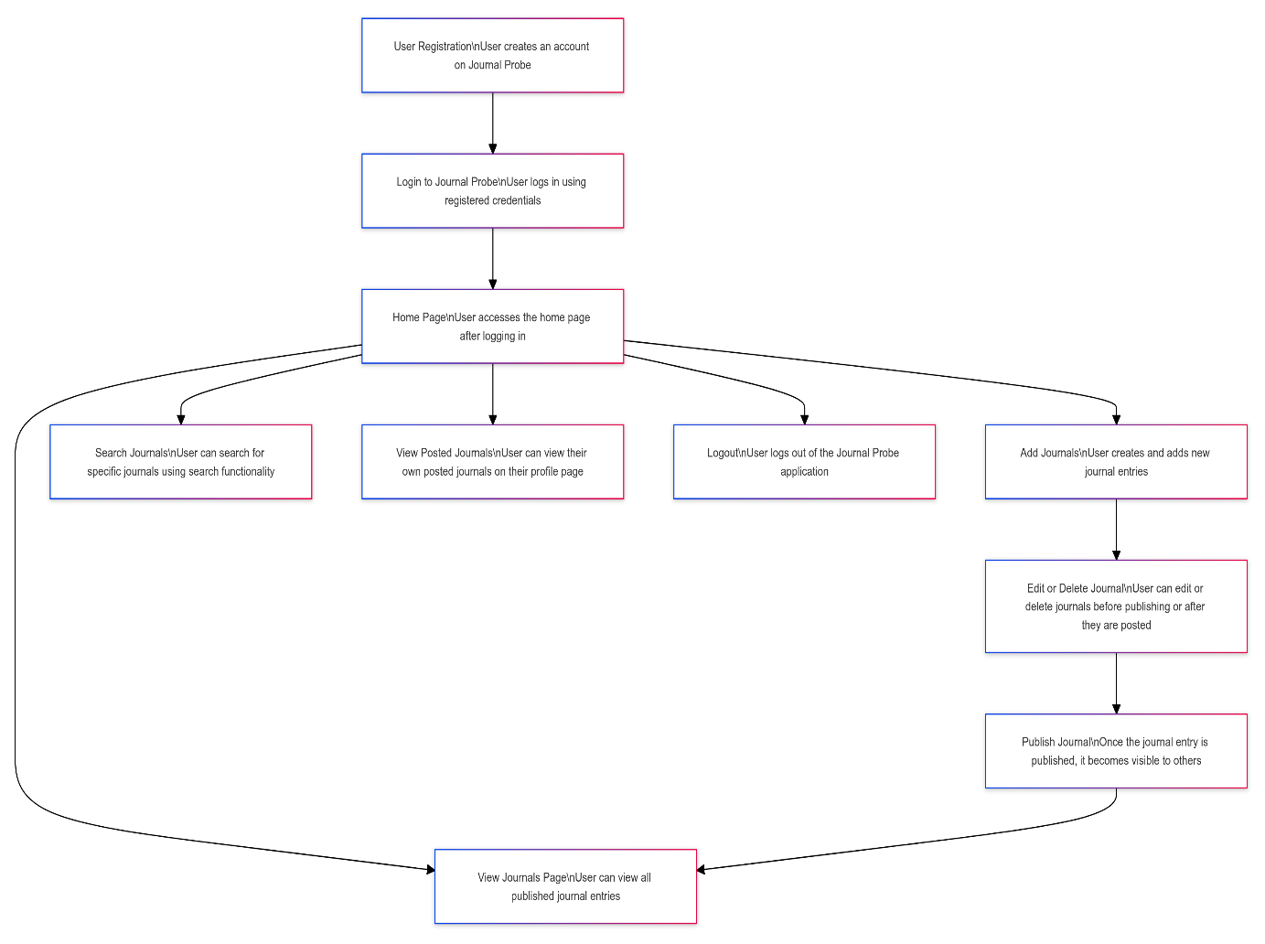
FIG 5.1 PROCESS FLOW DIAGRAM
5.2 SIGNUP / REGISTRATION PAGE
This page allows new users to register an account by entering their username, password, and email address. The system validates the information, creating the account if accurate, or prompting users to correct any errors before proceeding.
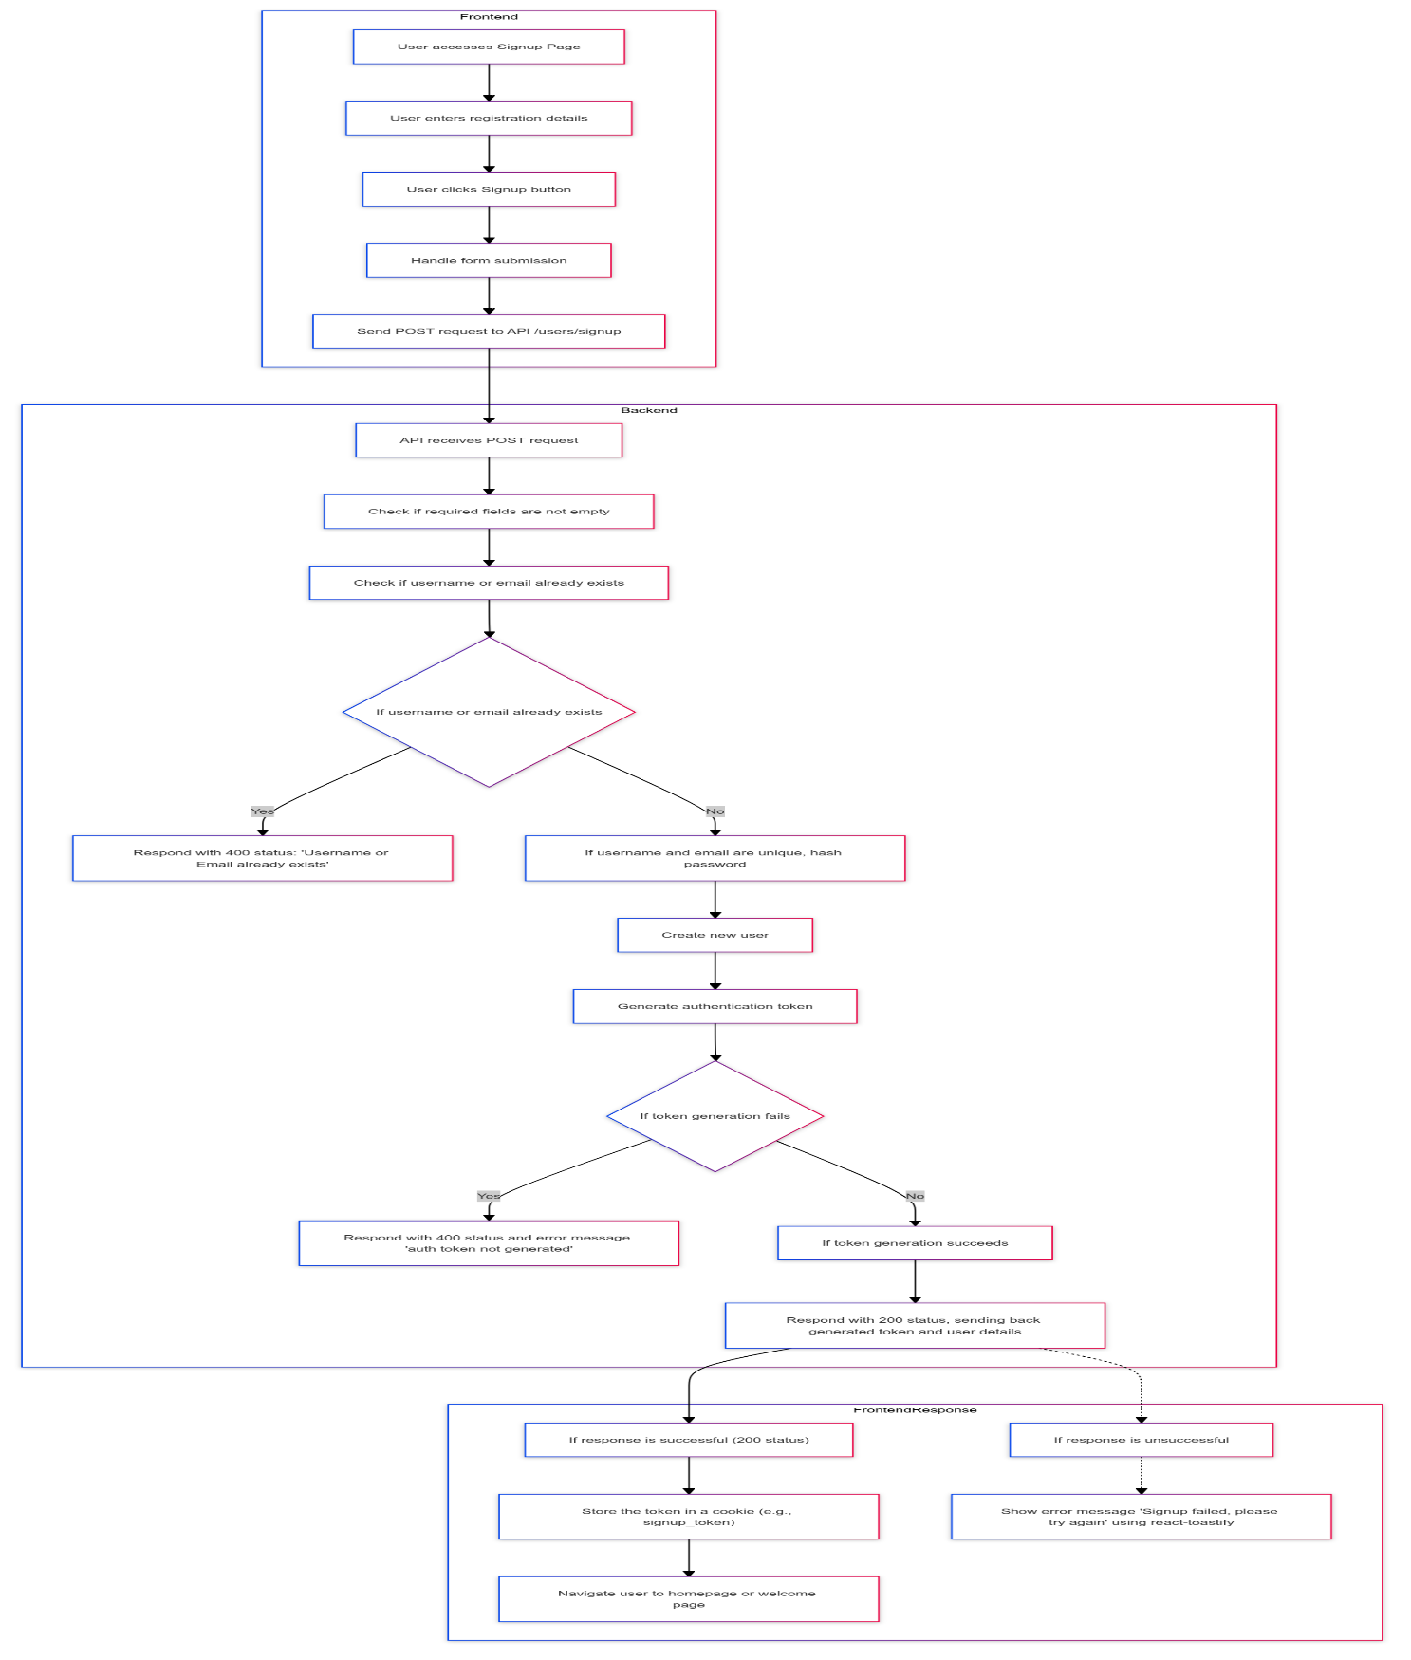
FIG 5.2 SIGNUP / REGISTRATION FLOW DIAGRAM
5.3 LOGIN PAGE
Users must enter their username and password, which the system validates against stored credentials. If correct, access is granted; if incorrect, an error message prompts the user to try logging in again.
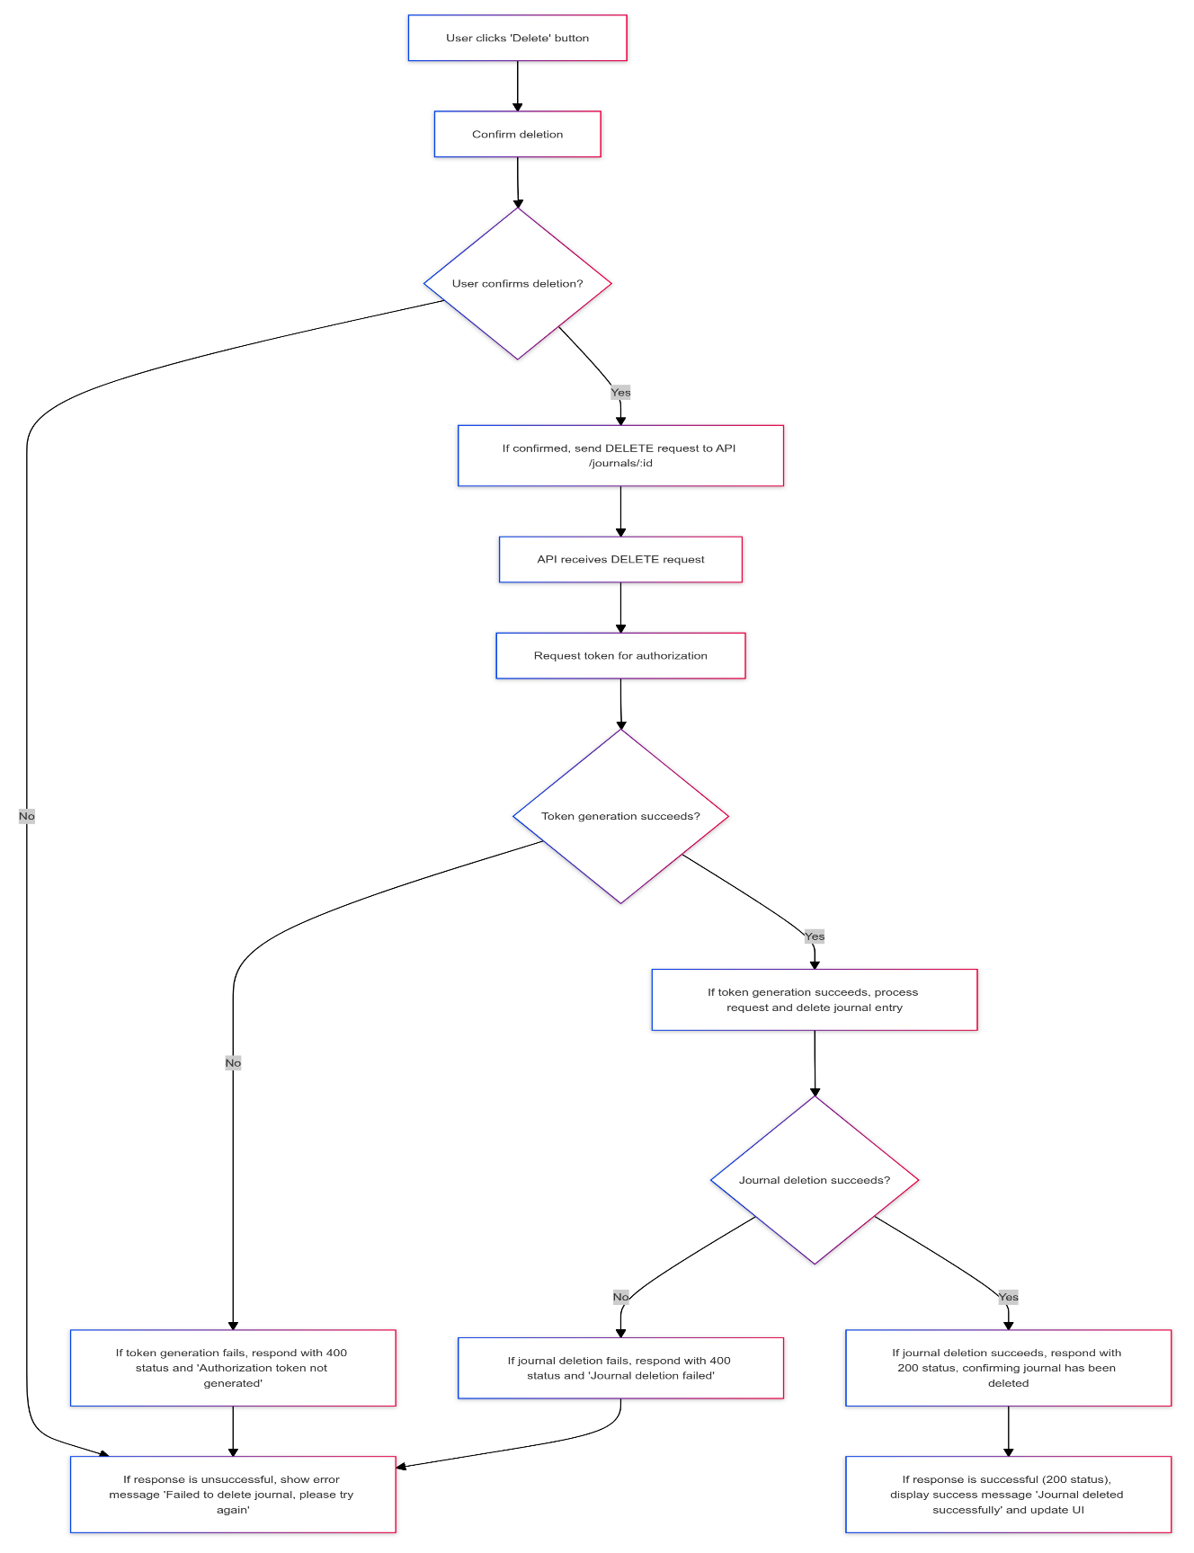
FIG 5.3 LOGIN FLOW DIAGRAM
5.4 HOME PAGE
The Home page offers users easy navigation to the Add Journal, Contact Us, Journals, and Profile pages, enabling a seamless experience while managing their journal entries and connecting with the platform.
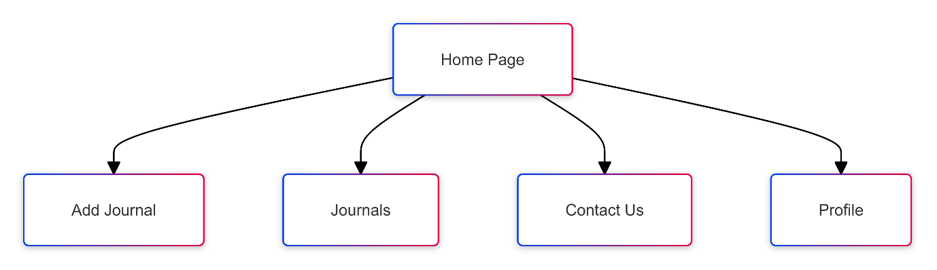
FIG 5.4 HOME FLOW DIAGRAM

5.5 ADD JOURNAL PAGE
This page allows users to create journal entries by providing a title, description, author name, and images. Users can publish their entries to make them visible on the Journals Page and can easily edit or delete them as needed to keep their journal personalized and relevant.
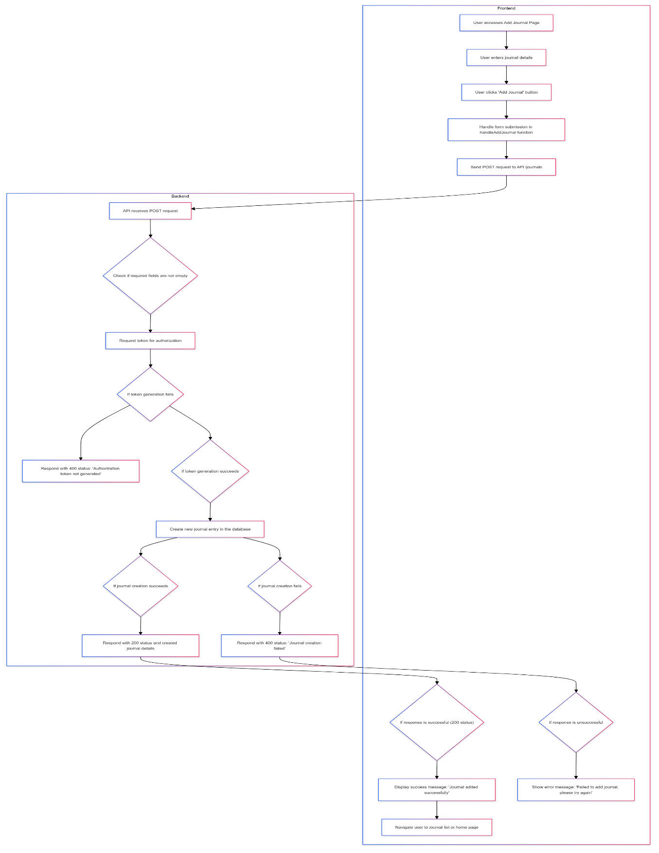
FIG 5.5.1 ADD JOURNAL FLOW DIAGRAM
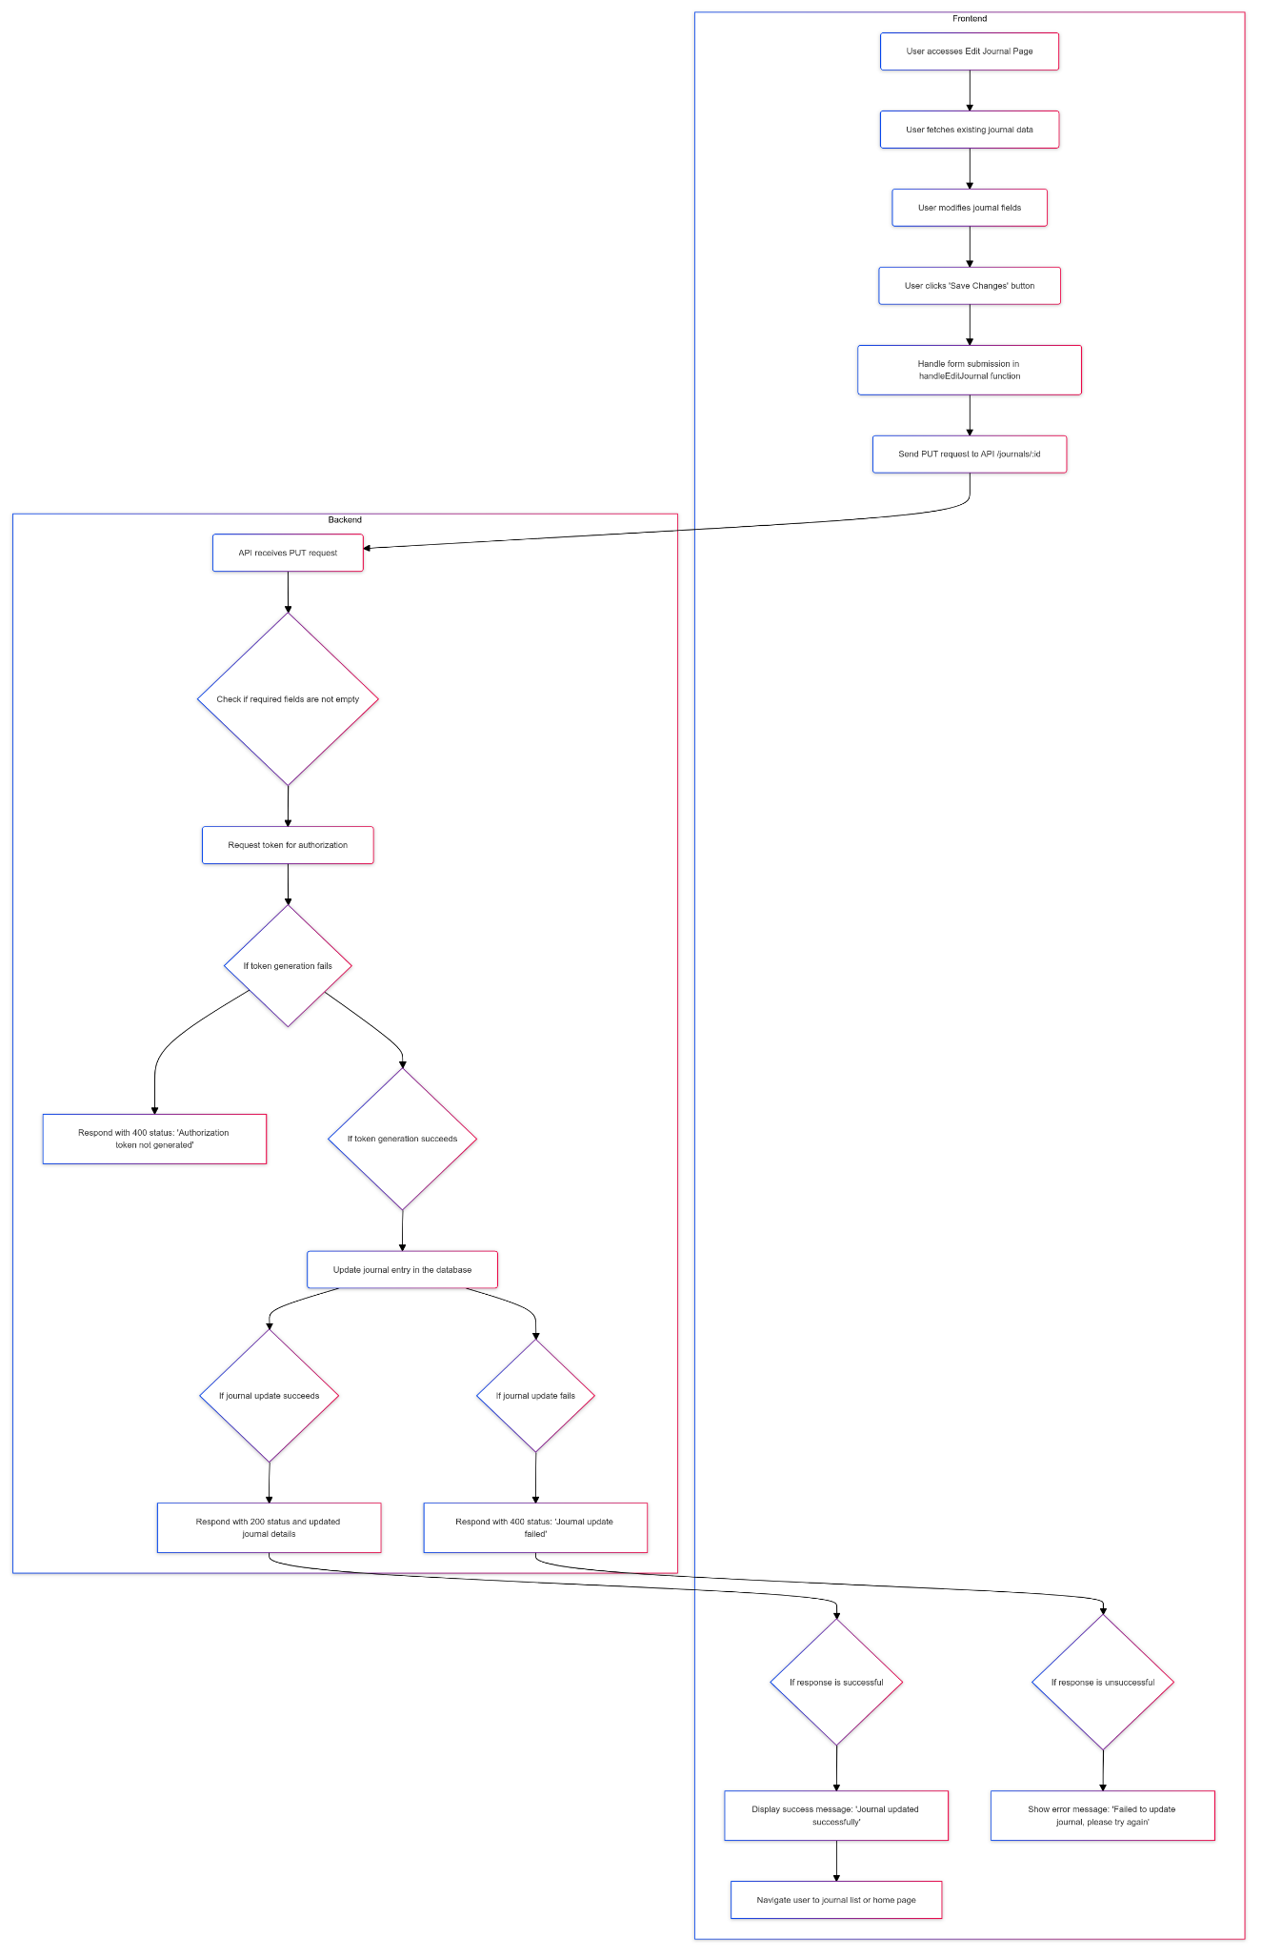
FIG 5.5.2 EDIT JOURNAL FLOW DIAGRAM
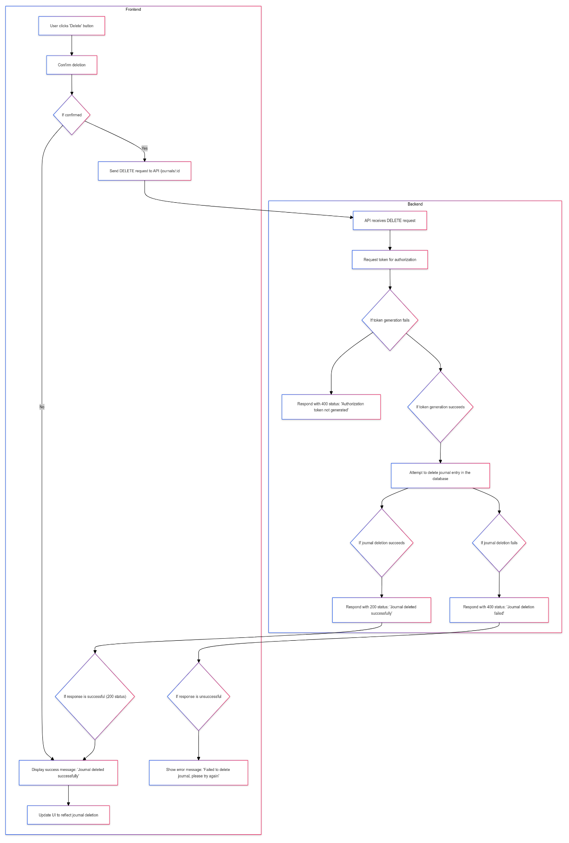
FIG 5.5.3 DELETE JOURNAL FLOW DIAGRAM
5.6 JOURNALS VIEW PAGE
The journal view allows us to view the posted journal. It provides a clear display of the journal entries.
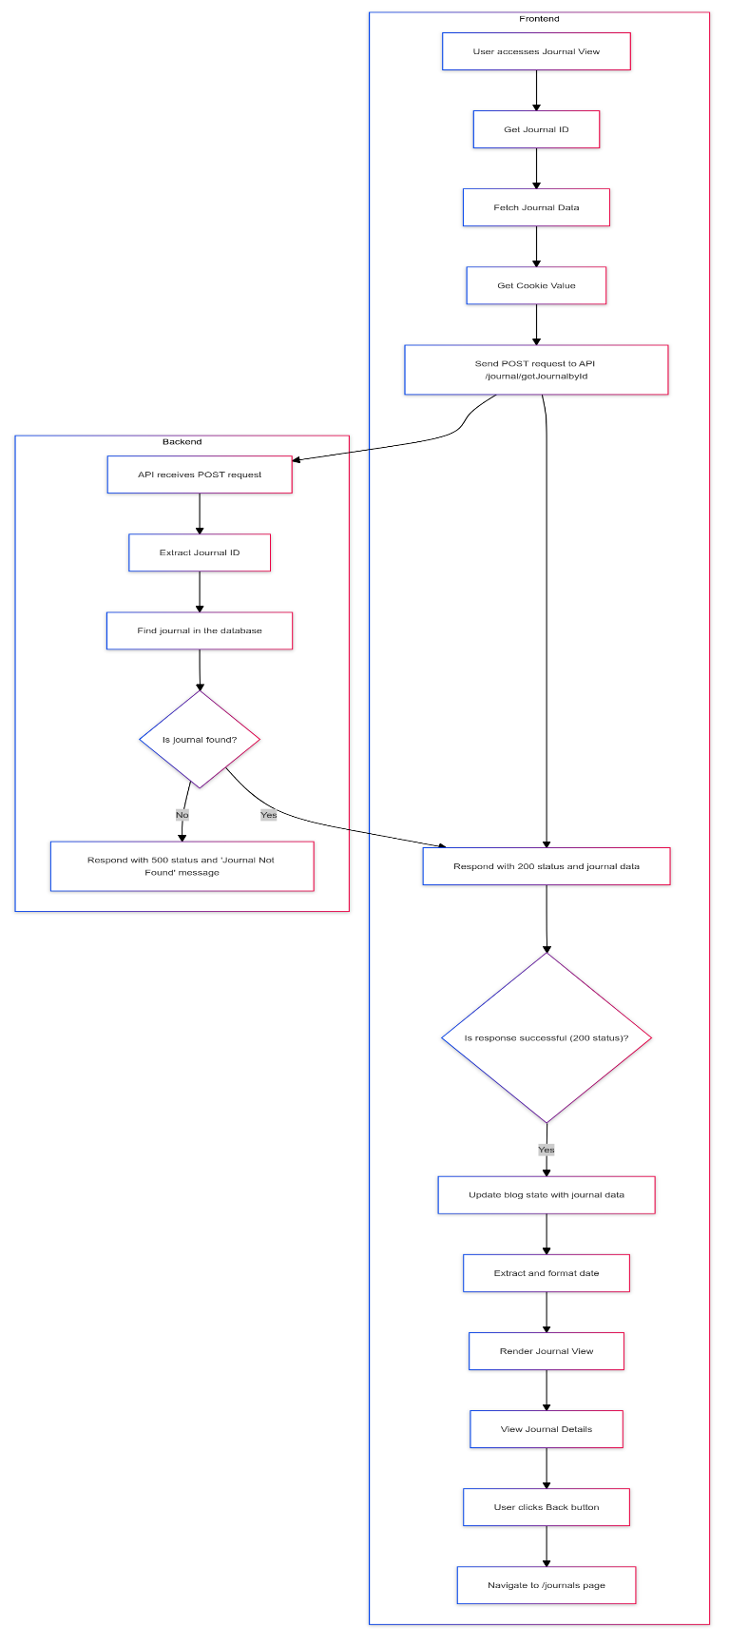
FIG 5.6 JOURNALS VIEW FLOW DIAGRAM
5.7 CONTACT US PAGE
The Contact Us page provides a simple form and contact details for users to reach out with inquiries or feedback.
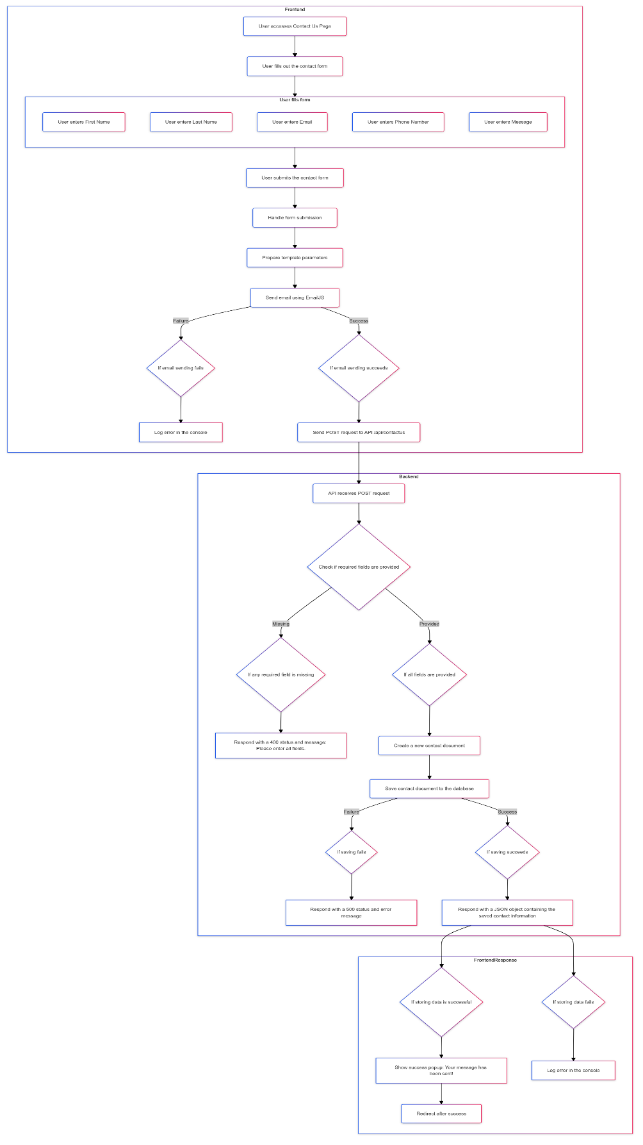
FIG 5.7 CONTACT US FLOW DIAGRAM
5.8 PROFILE PAGE
The Profile page displays the username, showcases the user's posted journals, and provides options to edit or delete each journal, along with a logout option for easy account management.
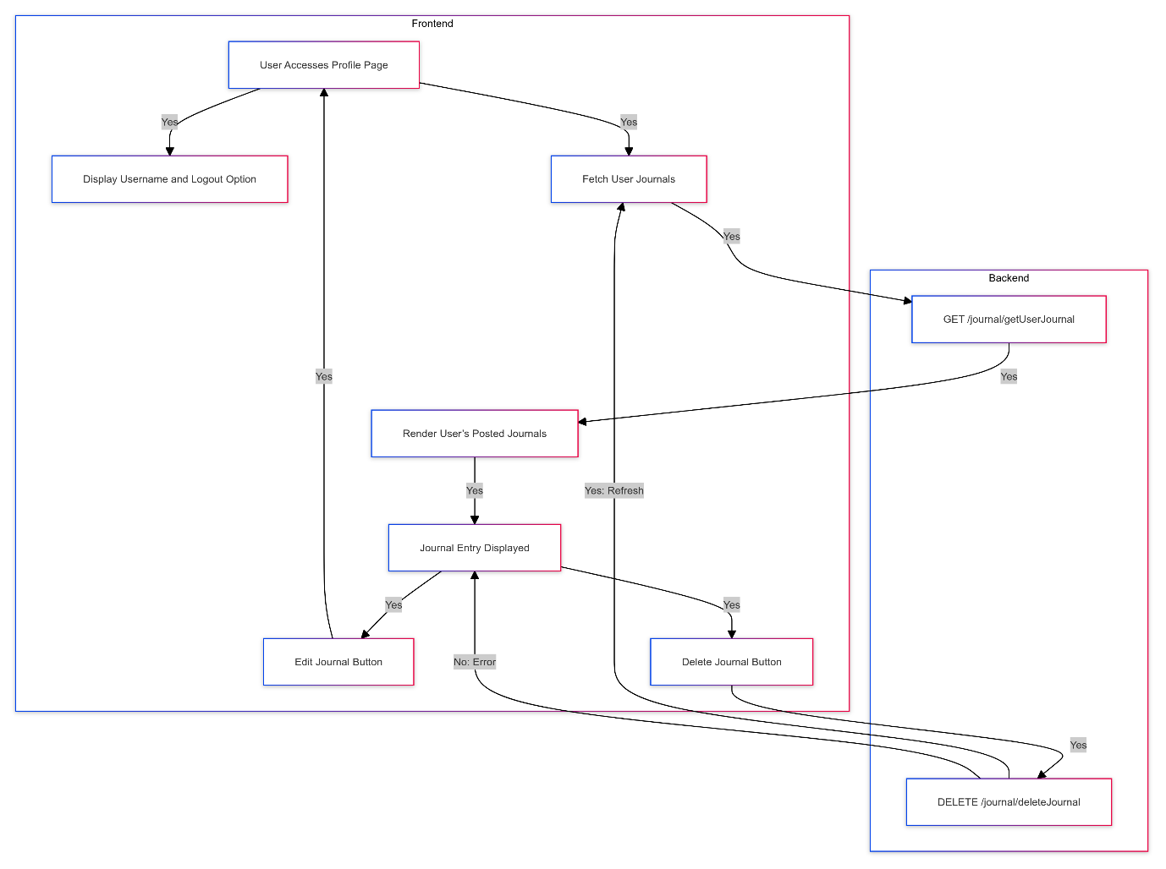
FIG 5.8 PROFILE FLOW DIAGRAM

IMPLEMENTATION AND RESULT
CHAPTER 6
IMPLEMENTATION AND RESULT
This chapter gives a description about the output that we produced by developing the website of our idea.
6.1 SIGNUP / REGISTRATION PAGE
If a user doesn’t have an account, they can create a new one by clicking on the "Sign Up" link on the login page. Upon clicking, the user is redirected to the signup page, where they need to provide their username, email address, and password. These inputs are validated before the account is successfully registered in the system.

FIG 6.1 SIGNUP / REGISTRATION
6.2 LOGIN PAGE
When a user enters the website, they are prompted to provide their username and password. These credentials are then verified against the information stored in the system from when the user initially created their account.

FIG 6.2 LOGIN
6.3 HOME PAGE
The Home page offers users easy navigation to the Add Journal, Contact Us, Journals, and Profile pages, enabling a seamless experience while managing their journal entries and connecting with the platform.

FIG 6.3 HOME

6.4 ADD JOURNAL PAGE
The "Add Journal" page allows users to enter a title, description, author name, and multimedia content while providing AI assistance for content generation if needed.
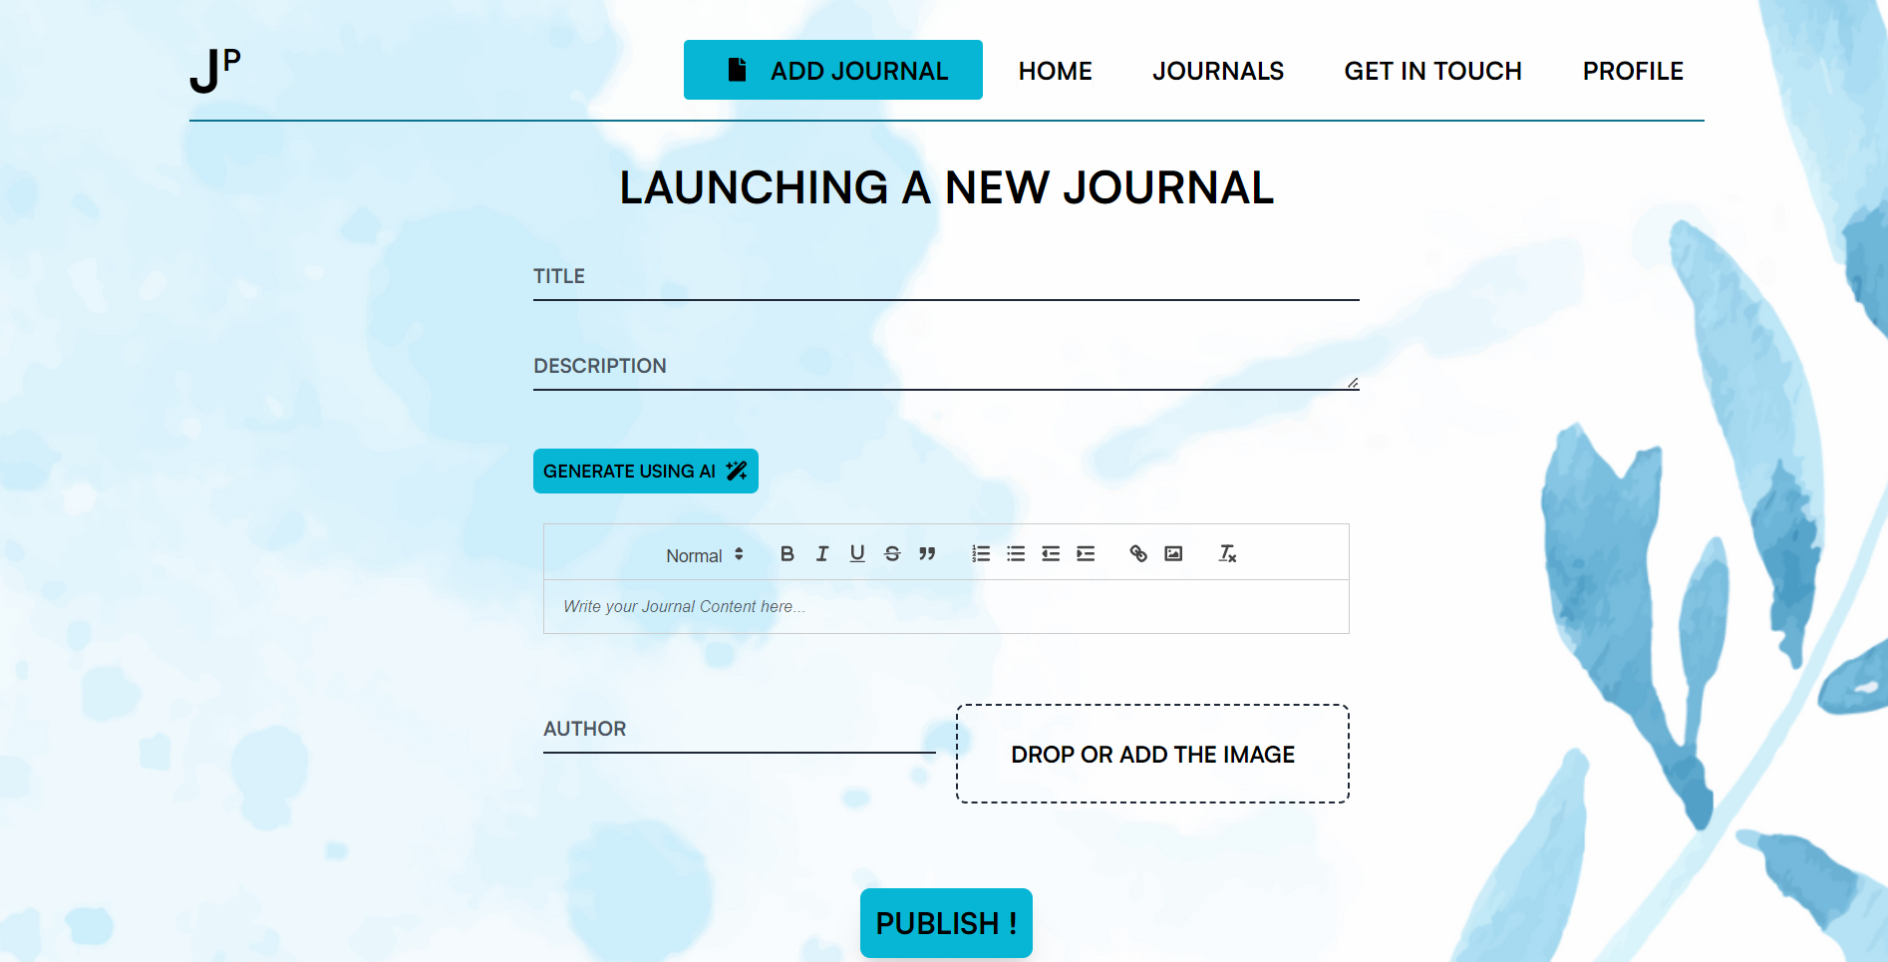
FIG 6.4 ADD JOURNAL
6.5 JOURNALS VIEW
In the journal view, we can see the posted journals of all users, along with the option to view each journal in detail.
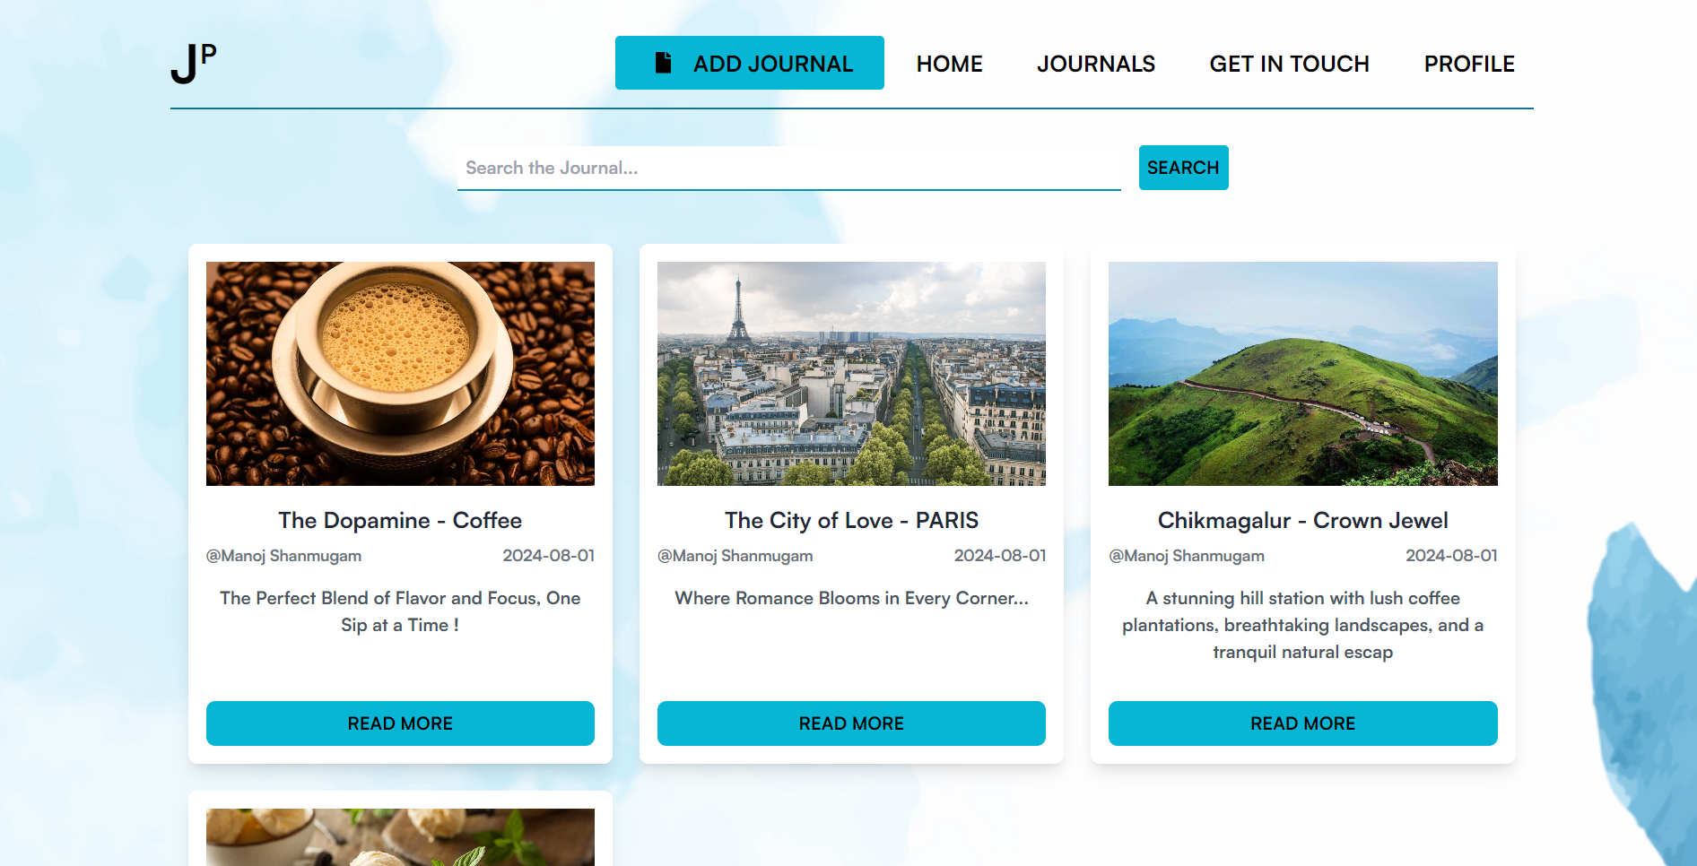
FIG 6.5.1 JOURNALS VIEW
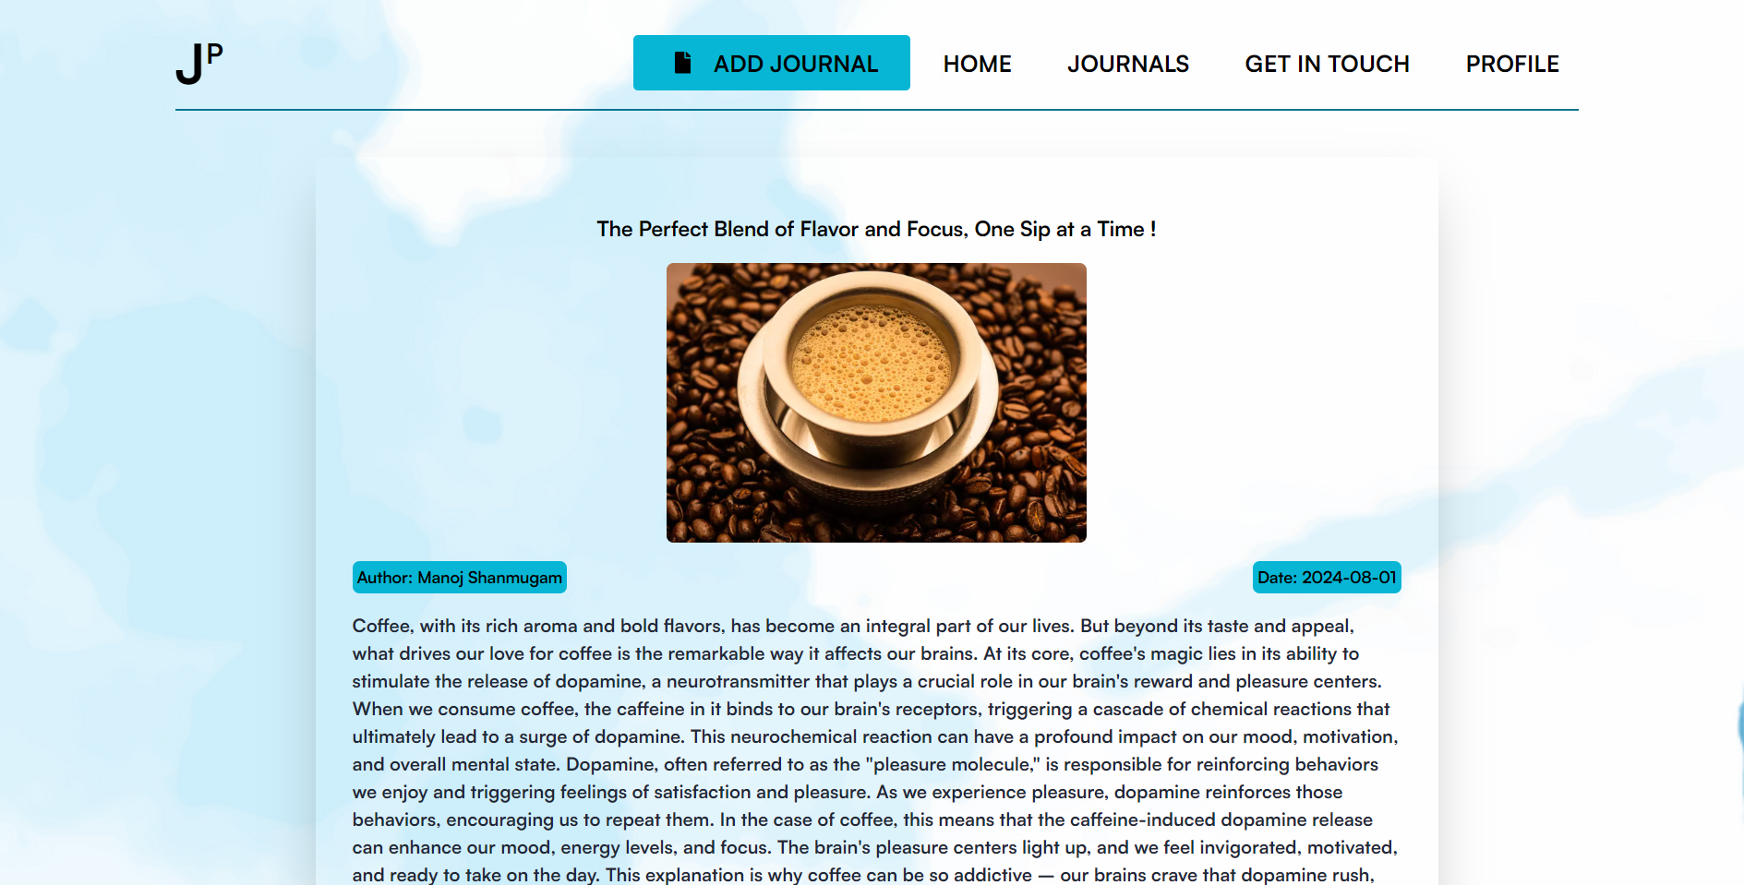
FIG 6.5.2 VIEWING COMPLETE JOURNAL
6.6 CONTACT US PAGE
The Contact Us page provides a simple form and contact details for users to reach out with inquiries or feedback.
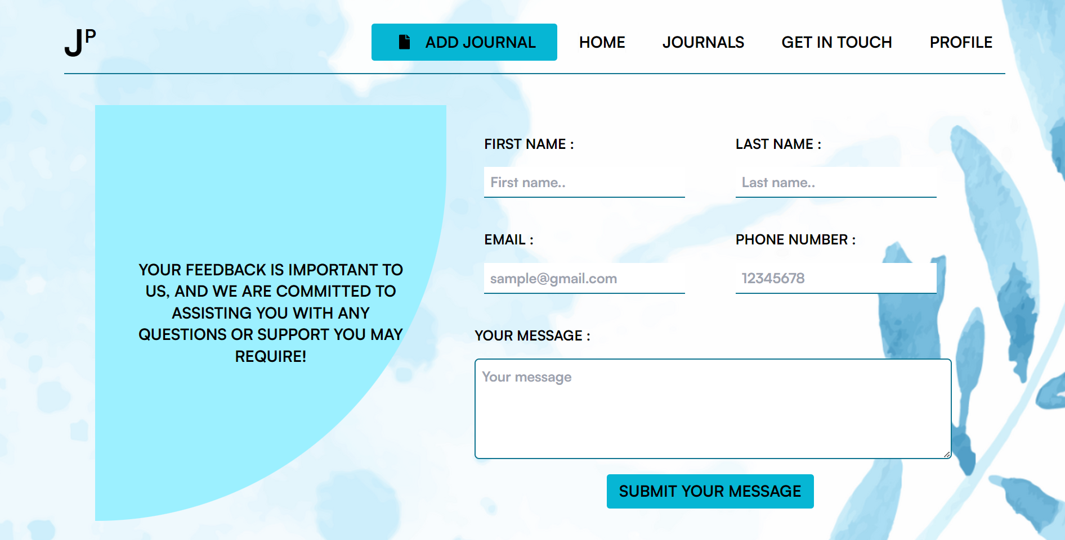
FIG 6.6 CONTACT US

6.7 PROFILE PAGE
The Profile page displays the username, showcases the user's posted journals, and provides options to edit or delete each journal, along with a logout option for easy account management.
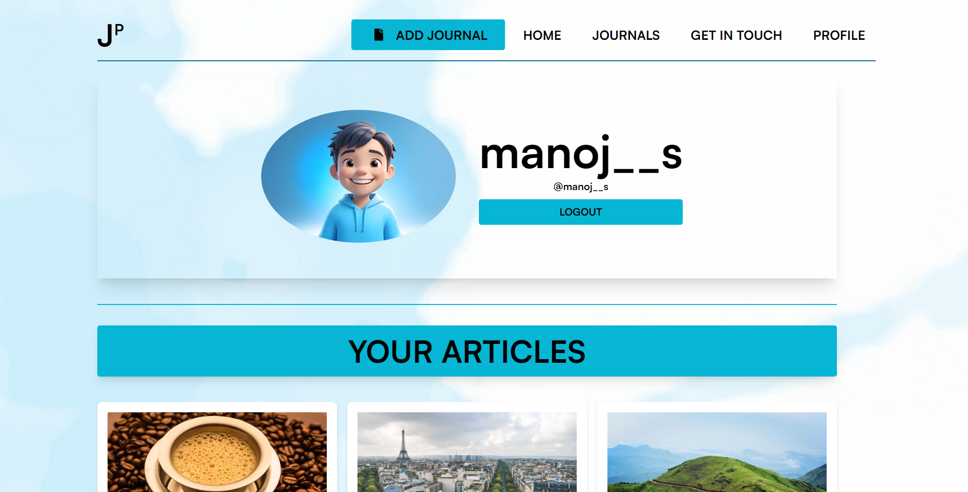
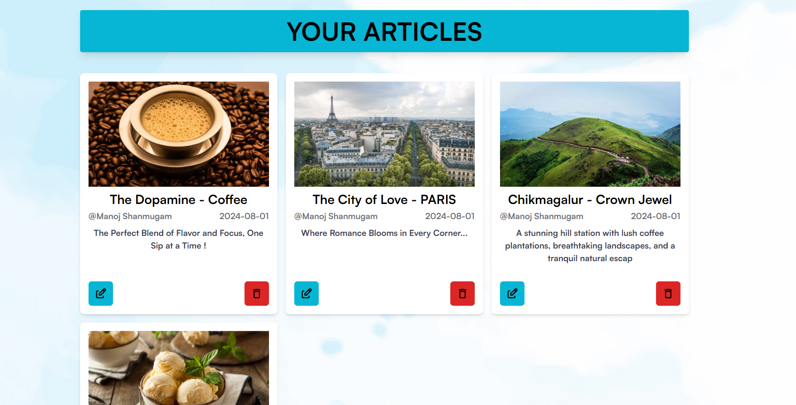
FIG 6.7 PROGILE

6.8 CODING
6.8.1 Signup / Registration Page
import React, {useState} from 'react';
import { useNavigate } from 'react-router-dom';
import loginImg from '../../assets/image.png';
import { ToastContainer, toast } from 'react-toastify';
import 'react-toastify/dist/ReactToastify.css';
import axios from 'axios';
const SignupForm = () => {
const navigate = useNavigate();
const toSignup = () => {
navigate('/login');
};
const [userName, setUserName] = useState('');
const [email, setEmail] = useState('');
const [password, setPassword] = useState('');
const [confirmPassword, setConfirmPassword] = useState('');
const validateEmail = (email) => {
const emailRegex = /^[^\s@]+@[^\s@]+\.[^\s@]+$/;
return emailRegex.test(email);
};
const validatePassword = (password) => {
const passwordRegex = /^(?=.*\d)(?=.*[a-z])(?=.*[A-Z])(?=.*[@#$%^&+=]).{8,}$/;
return passwordRegex.test(password);
};
const handleSubmit = async (e) => {
e.preventDefault();
if (!validateEmail(email)) {
toast.error("Invalid email format");
return;
}
if (!validatePassword(password)) {
toast.error("Password must be at least 8 characters long, include an uppercase letter, a lowercase letter, a number, and a special character");
return;
}
if (password !== confirmPassword) {
toast.error("Passwords do not match");
return;
}
try {
const response = await axios.post(`${import.meta.env.VITE_BASE_URL}users/signup`, {
userName, email, password
}, {
headers: {
'Content-Type': 'application/json'
}
});
console.log(response);
if (response.status === 200) {
toast.success("Registered Successfully");
document.cookie = `journal_token=${response.data.message.token}`;
navigate('/');
}
} catch (err) {
toast.error("User already exists");
}
};
return (
<>
<div
style={{ 'animation': 'slideInFromLeft 1s ease-out' }}
className="md:w-[50%] bg-gradient-to-r shadow-2xl overflow-hidden p-10 space-y-8">
<h2
style={{ 'animation': 'appear 2s ease-out' }}
className="text-center text-4xl font-extrabold text-gray-900">
REGISTER
</h2>
<p style={{ 'animation': 'appear 3s ease-out' }} className="text-center text-gray-900">
GET STARTED WITH YOUR ACCOUNT
</p>
<form method="POST" action="#" className="space-y-6">
<div className="relative">
<input
placeholder="Username"
className="peer h-10 w-full border-b-2 border-solid border-gray-300 text-black bg-transparent placeholder-transparent focus:outline-none focus:border-gray-500"
required
id="name"
name="name"
type="text"
onChange={(e) => setUserName(e.target.value)}
/>
<label
className="absolute left-0 -top-3.5 text-gray-500 text-sm transition-all peer-placeholder-shown:text-base peer-placeholder-shown:text-gray-400 peer-placeholder-shown:top-2 peer-focus:-top-3.5 peer-focus:text-cyan-500 peer-focus:text-sm"
htmlFor="name">
USERNAME
</label>
</div>
<div className="relative">
<input
placeholder="Email"
className="peer h-10 w-full border-b-2 border-solid border-gray-300 text-black bg-transparent placeholder-transparent focus:outline-none focus:border-gray-500"
required
id="email"
name="email"
type="email"
onChange={(e) => setEmail(e.target.value)}
/>
<label
className="absolute left-0 -top-3.5 text-gray-900 text-sm transition-all peer-placeholder-shown:text-base peer-placeholder-shown:text-gray-400 peer-placeholder-shown:top-2 peer-focus:-top-3.5 peer-focus:text-cyan-500 peer-focus:text-sm"
htmlFor="email">
EMAIL
</label>
</div>
<div className="relative">
<input
placeholder="Password"
className="peer h-10 w-full border-b-2 border-solid border-gray-300 text-black bg-transparent placeholder-transparent focus:outline-none focus:border-gray-500"
required
id="password"
name="password"
type="password"
onChange={(e) => setPassword(e.target.value)}
/>
<label
className="absolute left-0 -top-3.5 text-gray-900 text-sm transition-all peer-placeholder-shown:text-base peer-placeholder-shown:text-gray-400 peer-placeholder-shown:top-2 peer-focus:-top-3.5 peer-focus:text-cyan-500 peer-focus:text-sm"
htmlFor="password">
PASSWORD
</label>
</div>
<div className="relative">
<input
placeholder="Confirm Password"
className="peer h-10 w-full border-b-2 border-solid border-gray-300 text-black bg-transparent placeholder-transparent focus:outline-none focus:border-gray-500"
required
id="confirmPassword"
name="confirmPassword"
type="password"
onChange={(e) => setConfirmPassword(e.target.value)}
/>
<label
className="absolute left-0 -top-3.5 text-gray-900 text-sm transition-all peer-placeholder-shown:text-base peer-placeholder-shown:text-gray-400 peer-placeholder-shown:top-2 peer-focus:-top-3.5 peer-focus:text-cyan-500 peer-focus:text-sm"
htmlFor="confirmPassword">
CONFIRM PASSWORD
</label>
</div>
<button
className="w-full py-2 px-4 bg-cyan-500 hover:bg-cyan-600 rounded-md shadow-lg text-black font-semibold transition duration-200"
type="submit"
onClick={(e) => handleSubmit(e)}>
REGISTER
</button>
<ToastContainer />
</form>
<div className="text-center text-gray-900">
HAVE AN ACCOUNT?
<button className="text-cyan-700 px-2 hover:underline" onClick={() => toSignup()}>
LOGIN
</button>
</div>
</div>
</>
);
};
const Signup = () => {
return (
<div>
<div className='flex items-center justify-center h-[86vh]'>
<div className='bg-white w-[55rem] h-[35rem] flex'>
<div className='hidden w-[50%] md:block'>
<img className="w-full" src={loginImg} alt="Login" />
</div>
<SignupForm />
</div>
</div>
</div>
);
};
export default Signup;
6.8.2 Login Page
import {useNavigate} from 'react-router-dom';
import loginImg from '../../assets/image.png'
import React, { useState } from 'react'
import axios from 'axios'
import { ToastContainer, toast } from 'react-toastify';
import 'react-toastify/dist/ReactToastify.css';
const LoginForm =()=>{
const [userName, setUserName] = useState('')
const [password, setPassword] = useState('')
const navigate = useNavigate()
const toSignup =()=>{
navigate('/signup')
}
const handleSubmit = async(e) =>{
e.preventDefault()
try{
const response = await axios.post(`${import.meta.env.VITE_BASE_URL}users/login`, {
userName, password
}, {
headers: {
'Content-Type': 'application/json'
}
})
if(response.status === 200){
document.cookie = `journal_token=${response.data.message.token}`
console.log('Login Successful')
navigate('/')
}
}
catch(err){
toast.error("Wrong username or password")
}
}
return (
<div
style={{'animation': 'slideInFromLeft 1s ease-out'}}
className="w-[100%] flex flex-col justify-center md:w-[50%] bg-gradient-to-r rounded-rb-xl shadow-2xl overflow-hidden p-10 space-y-8 ">
<h2
style={{'animation': 'appear 2s ease-out'}}
className="text-center text-4xl font-extrabold text-gray-900"
>
LOGIN
</h2>
<p style={{'animation': 'appear 3s ease-out'}} className="text-center text-gray-900">
SIGN IN YOUR ACCOUNT
</p>
<form method="POST" action="#" className="space-y-6">
<div className="relative">
<input
placeholder="john@example.com"
className="peer h-10 border-solid w-full border-b-2 border-gray-300 text-black bg-transparent placeholder-transparent focus:outline-none focus:border-gray-500"
required=""
id="email"
name="email"
type="text"
value={userName}
onChange={(e) => setUserName(e.target.value)}
/>
<label
className="absolute left-0 -top-3.5 text-gray-500 text-sm transition-all peer-placeholder-shown:text-base peer-placeholder-shown:text-gray-400 peer-placeholder-shown:top-2 peer-focus:-top-3.5 peer-focus:text-cyan-500 peer-focus:text-sm"
htmlFor="email"
>USER NAME</label
>
</div>
<div className="relative">
<input
placeholder="Password"
className="peer h-10 w-full border-solid border-b-2 border-gray-300 text-black bg-transparent placeholder-transparent focus:outline-none focus:border-gray-500"
required=""
id="password"
name="password"
type="password"
value={password}
onChange={(e) => setPassword(e.target.value)}
/>
<label
className="absolute left-0 -top-3.5 text-gray-900 text-sm transition-all peer-placeholder-shown:text-base peer-placeholder-shown:text-gray-400 peer-placeholder-shown:top-2 peer-focus:-top-3.5 peer-focus:text-cyan-500 peer-focus:text-sm"
htmlFor="password"
>PASSWORD</label
>
</div>
<div className="flex items-center justify-between">
<label className="flex items-center text-sm text-gray-200">
</label>
{/* <a className="text-sm text-cyan-500 hover:underline" href="#"
>Forgot your password?</a
> */}
</div>
<button
className="w-full py-2 px-4 bg-cyan-500 hover:bg-cyan-600 rounded-md shadow-lg text-black font-semibold transition duration-200"
type="submit"
onClick={(e)=>handleSubmit(e)}
// onClick={(e)=>handleEvents(e)}
>
SIGN IN
</button>
</form>
<div className="text-center text-gray-900"> Don't have an account?
<button className="text-cyan-700 px-2 hover:underline" onClick={toSignup}>SIGN UP</button>
</div>
<ToastContainer/>
</div>
)
}
const Login = () => {
return (
<div className=''>
<div className='flex items-center justify-center rounded-2xl h-[86vh]'>
<div className='bg-white w-[55rem] h-[35rem] flex '>
<div className='w-[50%] hidden md:block'>
<img src={loginImg}></img>
</div>
<LoginForm/>
</div>
</div>
</div>
)
}
export default Login
6.8.3 Home Page
import React from 'react'
import homeimg from '../../assets/homepage.png'
import { TypeAnimation } from 'react-type-animation';
import { useNavigate } from 'react-router';
const Welcome = () => {
const navigate = useNavigate()
const toExplore=()=>{
navigate('/journals')
}
return (
<section className='h-[70vh] mt-20 bg-transparent'>
<div className='h-full flex justify-center items-center relative pb-10'>
<div className='flex flex-col items-center px-10 z-10 text-center max-w-4xl mx-auto'>
<p className='text-5xl font-extrabold text-black mb-6 leading-tight'>
<TypeAnimation
sequence={[
'WELCOME TO JOURNAL PROBE: A BEACON OF SCHOLARLY EXCELLENCE',
1000,
]}
wrapper="span"
speed={50}
repeat={Infinity}
/>
</p>
<p className='text-lg text-black mb-10 max-w-2xl'>
Join a global community of scholars and innovators in pushing the boundaries of knowledge. Discover, share, and grow with us.
</p>
<button
className='w-52 h-14 bg-cyan-500 text-black rounded text-xl font-semibold shadow-lg hover:bg-cyan-700 transition duration-300 transform hover:scale-105'
onClick={toExplore}
>
EXPLORE
</button>
</div>
<div className='absolute inset-0 z-0'>
{/* Add background image or illustration here */}
{/* <img src={homeimg} alt="" className='w-full h-full object-cover opacity-10' /> */}
</div>
</div>
</section>
)
}
export default Welcome;
6.8.4 Add Journal Page
import React, { useEffect, useState } from 'react';
import ReactQuill from 'react-quill';
import 'react-quill/dist/quill.snow.css';
import axios from 'axios';
import { useNavigate, useParams } from 'react-router-dom';
import { ToastContainer, toast } from 'react-toastify';
import 'react-toastify/dist/ReactToastify.css';
import { FaWandMagicSparkles } from "react-icons/fa6";
const AddJournals = () => {
const modules = {
toolbar: [
[{ 'header': [1, 2, false] }],
['bold', 'italic', 'underline', 'strike', 'blockquote'],
[{ 'list': 'ordered' }, { 'list': 'bullet' }, { 'indent': '-1' }, { 'indent': '+1' }],
['link', 'image'],
['clean']
],
};
const formats = [
'header',
'bold', 'italic', 'underline', 'strike', 'blockquote',
'list', 'bullet', 'indent',
'link', 'image'
];
const navigate = useNavigate();
const { id } = useParams();
const [title, setTitle] = useState('');
const [description, setDescription] = useState('');
const [journalContent, setJournalContent] = useState('');
const [author, setAuthor] = useState('');
const [image, setImage] = useState(null);
const [data, setData] = useState([]);
const [generated, setGenerated] = useState('');
const [_id, setId] = useState('');
// Function to get cookie value
function getCookieValue(name) {
const cookies = document.cookie.split(';');
for (let cookie of cookies) {
cookie = cookie.trim();
if (cookie.startsWith(name + '=')) {
return cookie.substring(name.length + 1);
}
}
return null;
}
// Fetch old data for editing
const fetchOldData = async () => {
const token = getCookieValue('journal_token');
try {
const data = await axios.post(`${import.meta.env.VITE_BASE_URL}journal/getJournalbyId`, {
id: id
},
{
headers: {
'Authorization': `Bearer ${token}`,
'Content-Type': 'application/json'
}
});
setId(_id);
setTitle(data.data.message.title);
setAuthor(data.data.message.author);
setImage(data.data.message.image);
setDescription(data.data.message.description);
setJournalContent(data.data.message.journalContent);
} catch (err) {
console.log(err.message);
}
};
useEffect(() => {
if (id) {
fetchOldData();
}
}, [id]);
// Function to extract generated content
const extractGen = (content) => {
const cleanedContent = content.replace(/\n/g, '').replace(/\*/g, '');
const sentences = cleanedContent.split(/[.!?]+/);
sentences.shift();
sentences.pop();
const modifiedContent = sentences.join('. ');
return modifiedContent;
};
// Handle content generation
const handleGenerate = async () => {
if (!title) {
return toast.error('Enter Title');
}
const token = getCookieValue('journal_token');
try {
const res = await axios.post(`${import.meta.env.VITE_BASE_URL}journal/generateblog`, {
data: title
},
{
headers: {
'Content-Type': 'application/json',
'Authorization': `Bearer ${token}`
}
});
const content = extractGen(res.data.message);
setJournalContent(content); // Set the generated content directly
} catch (err) {
console.log(err.message);
}
};
// Handle form submission
const handleSubmit = async (e) => {
e.preventDefault();
try {
const token = getCookieValue('journal_token');
if (!title || !description || !journalContent || !author) {
toast.error('Fill all the details');
return;
}
const response = await axios.post(`${import.meta.env.VITE_BASE_URL}journal/uploads`, {
id,
title,
description,
journalContent,
author,
image,
}, {
headers: {
'Authorization': `Bearer ${token}`,
'Content-Type': 'multipart/form-data'
}
});
if (response.status === 200) {
navigate('/home');
setJournalContent('');
}
} catch (err) {
console.log(err.message);
toast.error("Incomplete data");
}
};
// Handle file change
function handleFileChange(e) {
setImage(e.target.files[0]);
const fileNameSpan = document.getElementById('file-name');
const file = e.target.files[0];
if (file) {
fileNameSpan.textContent = file.name;
}
}
// Handle file drop
function handleDrop(e) {
e.preventDefault();
const files = e.dataTransfer.files;
handleFileChange({ target: { files } });
}
// Handle drag over event
function handleDragOver(e) {
e.preventDefault();
}
return (
<div className='p-4 '>
<div className='flex items-center flex-col'>
<div className='text-4xl p-4'>LAUNCHING A NEW JOURNAL</div>
<div className='flex flex-col gap-y-[2rem] w-[80%] mt-[1rem] items-center '>
<div className='relative w-full sm:w-[70%]'>
<input type='text' className='peer h-10 border-solid w-full border-b-2 border-gray-800 text-black bg-transparent placeholder-transparent focus:outline-none focus:border-gray-800' placeholder=''
value={title} name='title' onChange={(e) => { setTitle(e.target.value) }} required
/>
<label className="absolute left-0 -top-4 text-grey-800 text-sm transition-all peer-placeholder-shown:text-base peer-placeholder-shown:text-gray-600 peer-placeholder-shown:top-2 peer-focus:-top-3.5 peer-focus:text-cyan-700 peer-focus:text-sm">TITLE</label>
</div>
<div className='relative w-full sm:w-[70%]'>
<textarea type='text' className='peer h-10 border-solid w-full border-b-2 border-gray-800 text-black bg-transparent placeholder-transparent focus:outline-none focus:border-gray-800' placeholder=''
value={description} name='description'
onChange={(e) => {
const words = e.target.value.trim().split(/\s+/); // Split by whitespace
if (words.length <= 15) { // Limit to 15 words
setDescription(e.target.value);
} else {
toast.error('Description must be 12-15 words');
}
}} required
/>
<label className="absolute left-0 -top-4 text-grey-800 text-sm transition-all peer-placeholder-shown:text-base peer-placeholder-shown:text-gray-600 peer-placeholder-shown:top-2 peer-focus:-top-5 peer-focus:text-cyan-700 peer-focus:text-sm">DESCRIPTION</label>
</div>
<div className='w-full sm:w-[70%] flex flex-col items-start gap-4 text-lg m-2'>
<div className='flex justify-between w-full items-center'>
<button onClick={handleGenerate} className='flex items-center gap-x-[0.5rem] bg-cyan-500 p-[0.5rem] rounded-md '>
<span className='text-sm'>GENERATE USING AI</span>
<FaWandMagicSparkles />
</button>
</div>
<ReactQuill
modules={modules}
formats={formats}
name='journalContent'
placeholder='Write your Journal Content here...'
className='w-full p-2 border-2 border-gray-300 bg rounded-lg h-30'
value={journalContent} onChange={(e) => { setJournalContent(e) }}
required
/>
</div>
<div className='flex w-full sm:w-[70%] flex-col sm:flex-row'>
<div className='relative w-full sm:w-[50%] flex flex-col items-start gap-4 text-lg m-2'>
<input type='text' className='peer h-10 border-solid w-full border-b-2 border-gray-800 text-black bg-transparent placeholder-transparent focus:outline-none focus:border-gray-800' placeholder='' required
value={author} name='author' onChange={(e) => { setAuthor(e.target.value) }}
/>
<label className="absolute left-0 -top-4 text-grey-800 text-sm transition-all peer-placeholder-shown:text-base peer-placeholder-shown:text-gray-600 peer-placeholder-shown:top-2 peer-focus:-top-3.5 peer-focus:text-cyan-700 peer-focus:text-sm">AUTHOR</label>
</div>
<div
className='relative w-full sm:w-[50%] flex flex-col items-start gap-4 text-lg m-2'
onDrop={(e) => handleDrop(e)}
onDragOver={(e) => handleDragOver(e)}
>
<input
className='peer h-10 border-solid w-full border-b-2 border-gray-800 text-black bg-transparent placeholder-transparent focus:outline-none focus:border-gray-800 opacity-0 absolute inset-0 cursor-pointer'
placeholder=''
type='file'
name='image'
onChange={(e) => handleFileChange(e)}
/>
<div
className='w-full h-20 border-2 border-dashed border-gray-800 rounded-lg flex items-center justify-center cursor-pointer hover:bg-gray-100'
onClick={() => document.querySelector('input[name="image"]').click()}
>
{/* <label className="absolute left-0 -top-8 text-grey-800 text-sm transition-all peer-placeholder-shown:text-base peer-placeholder-shown:text-gray-600 peer-placeholder-shown:top-2 peer-focus:-top-3.5 peer-focus:text-cyan-700 peer-focus:text-sm">
UPLODE YOUR IMAGE
</label> */}
<span id="file-name" className="text-grey-800">DROP OR ADD THE IMAGE</span>
</div>
</div>
</div>
<button className='bg-cyan-500 px-3 py-3 rounded-lg mt-7 text-2xl shadow-xl' onClick={handleSubmit}>PUBLISH !</button>
</div>
</div>
<ToastContainer />
</div>
);
};
export default AddJournals;
6.8.5 Journals Page
import React, { useEffect, useState } from 'react';
import axios from 'axios';
import { Link } from 'react-router-dom';
const Search = ({ search, setSearch, handleSearch }) => {
return (
<div className='p-4'>
<input
type='text'
placeholder='Search the Journal...'
value={search}
className='border-0 border-b-2 border-solid border-b-cyan-600 md:min-w-[10rem] w-[50%] h-10 sm:p-2 '
onChange={(e) => setSearch(e.target.value)}
/>
<button className='h-10 w-20 bg-cyan-500 m-4 rounded' onClick={handleSearch}>SEARCH</button>
</div>
);
};
const Journals = () => {
const [data, setData] = useState([]);
const [search, setSearch] = useState('');
const [filteredData, setFilteredData] = useState([]);
function getCookieValue(name) {
const cookies = document.cookie.split(';');
for (let cookie of cookies) {
cookie = cookie.trim();
if (cookie.startsWith(name + '=')) {
return cookie.substring(name.length + 1);
}
}
return null;
}
const handleSearch = () => {
const value = search.toLowerCase();
if (value === "") {
setFilteredData(data);
return;
}
const filtered = data.filter(
item =>
item.title.toLowerCase().includes(value) ||
item.description.toLowerCase().includes(value) ||
item.author.toLowerCase().includes(value)
);
setFilteredData(filtered);
};
useEffect(() => {
const fetchData = async () => {
const token = getCookieValue('journal_token');
const response = await axios.get(`${import.meta.env.VITE_BASE_URL}journal/getJournals`, {
headers: {
'Authorization': `Bearer ${token}`,
'Content-Type': 'application/json'
}
});
setData(response.data.journals);
setFilteredData(response.data.journals); // Initialize filtered data
};
fetchData();
}, []);
useEffect(() => {
setFilteredData(data);
}, [data]);
return (
<>
<div>
<Search search={search} setSearch={setSearch} handleSearch={handleSearch} />
</div>
<div className='grid grid-cols-1 sm:grid-cols-2 lg:grid-cols-3 gap-6 p-4'>
{filteredData.map((journal, index) => (
<Link
to={`/${journal._id}`}
key={index}
className='bg-white shadow-lg rounded-lg overflow-hidden transition-transform duration-200 transform hover:scale-105 hover:shadow-2xl flex flex-col p-4 hover:bg-cyan-50'
>
<img src={journal.image} alt='journal' className='w-full h-[200px] object-cover mb-4' />
<div className='flex-grow'>
<h3 className='text-xl font-bold mb-2 text-gray-800'>{journal.title}</h3>
<div className='flex justify-between text-sm text-gray-500 mb-4'>
<span>@{journal.author}</span>
<span>{(journal.date).split("T")[0]}</span>
</div>
<p className='text-gray-600 mb-4'>{journal.description}</p>
</div>
<div className='mt-4'>
<button className='w-full px-4 py-2 bg-cyan-500 text-black rounded-lg hover:bg-cyan-600 transition duration-200'>READ MORE</button>
</div>
</Link>
))}
</div>
</>
);
};
export default Journals;
6.8.6 Journal View Page
import { useEffect, useState } from 'react';
import { useNavigate, useParams } from 'react-router-dom';
import axios from 'axios';
const JournalView = () => {
const { journalid } = useParams();
const [blog, setBlog] = useState({}); // Changed setBlogs to setBlog
const [date, setDate] = useState('');
const navigate = useNavigate();
const backClick = () => {
navigate('/journals');
};
function getCookieValue(name) {
const cookies = document.cookie.split(';');
for (let cookie of cookies) {
cookie = cookie.trim();
if (cookie.startsWith(name + '=')) {
return cookie.substring(name.length + 1);
}
}
return null;
}
useEffect(() => {
const fetchJournal = async () => {
const Token = getCookieValue('journal_token');
try {
const response = await axios.post(`${import.meta.env.VITE_BASE_URL}journal/getJournalbyId`, { id: journalid }, {
headers: {
'Content-Type': 'application/json',
'Authorization': `Bearer ${Token}` // Added backticks for template literal
}
});
setBlog(response.data.message); // Changed setBlogs to setBlog
} catch (error) {
console.error('Error fetching journal:', error); // Added error handling
}
};
fetchJournal();
}, [journalid]);
useEffect(() => {
if (blog.date) {
setDate(blog.date.split('T')[0]);
}
}, [blog.date]);
return (
<div className='flex justify-center items-center min-h-14 py-10'>
<div className='bg-transparent bg-opacity-90 shadow-2xl rounded-lg p-8 sm:w-4/5 w-full'>
<h1 className='text-3xl font-bold text-center text-black mb-4 '>{blog.blogTitle}</h1>
<p className='text-lg text-center text-grey mb-4' >{blog.description}</p>
<div className='flex justify-center mb-4'>
<img src={blog.image} className='rounded-md max-w-[40%] h-auto' alt='Journal Cover' />
</div>
<div className='flex justify-between text-black text-sm mb-4 font-semibold'>
<span className='bg-cyan-500 p-1 rounded-md'>Author: {blog.author}</span>
<span className='bg-cyan-500 p-1 rounded-md'>Date: {date}</span>
</div>
<div className='text-left text-gray-800 mb-4'>
<div dangerouslySetInnerHTML={{ __html: blog.journalContent }} className='prose lg:prose-xl'></div>
</div>
<div className='flex justify-center'>
<button onClick={backClick} className='px-6 py-3 bg-cyan-500 text-black font-semibold rounded-md hover:bg-cyan-600 transition duration-300'>
BACK TO JOURNALS
</button>
</div>
</div>
</div>
);
};
export default JournalView;
6.8.7 Blog View
import { useEffect, useState } from 'react';
import { useNavigate, useParams } from 'react-router-dom';
import axios from 'axios';
const JournalView = () => {
const { journalid } = useParams();
const [blog, setBlog] = useState({}); // Changed setBlogs to setBlog
const [date, setDate] = useState('');
const navigate = useNavigate();
const backClick = () => {
navigate('/journals');
};
function getCookieValue(name) {
const cookies = document.cookie.split(';');
for (let cookie of cookies) {
cookie = cookie.trim();
if (cookie.startsWith(name + '=')) {
return cookie.substring(name.length + 1);
}
}
return null;
}
useEffect(() => {
const fetchJournal = async () => {
const Token = getCookieValue('journal_token');
try {
const response = await axios.post(`${import.meta.env.VITE_BASE_URL}journal/getJournalbyId`, { id: journalid }, {
headers: {
'Content-Type': 'application/json',
'Authorization': `Bearer ${Token}` // Added backticks for template literal
}
});
setBlog(response.data.message); // Changed setBlogs to setBlog
} catch (error) {
console.error('Error fetching journal:', error); // Added error handling
}
};
fetchJournal();
}, [journalid]);
useEffect(() => {
if (blog.date) {
setDate(blog.date.split('T')[0]);
}
}, [blog.date]);
return (
<div className='flex justify-center items-center min-h-14 py-10'>
<div className='bg-transparent bg-opacity-90 shadow-2xl rounded-lg p-8 sm:w-4/5 w-full'>
<h1 className='text-3xl font-bold text-center text-black mb-4 '>{blog.blogTitle}</h1>
<p className='text-lg text-center text-grey mb-4' >{blog.description}</p>
<div className='flex justify-center mb-4'>
<img src={blog.image} className='rounded-md max-w-[40%] h-auto' alt='Journal Cover' />
</div>
<div className='flex justify-between text-black text-sm mb-4 font-semibold'>
<span className='bg-cyan-500 p-1 rounded-md'>Author: {blog.author}</span>
<span className='bg-cyan-500 p-1 rounded-md'>Date: {date}</span>
</div>
<div className='text-left text-gray-800 mb-4'>
<div dangerouslySetInnerHTML={{ __html: blog.journalContent }} className='prose lg:prose-xl'></div>
</div>
<div className='flex justify-center'>
<button onClick={backClick} className='px-6 py-3 bg-cyan-500 text-black font-semibold rounded-md hover:bg-cyan-600 transition duration-300'>
BACK TO JOURNALS
</button>
</div>
</div>
</div>
);
};
export default JournalView;
6.8.8 Contact Us Page
import React, { useState, useRef } from 'react';
import emailjs from 'emailjs-com';
import './ContactusStyles.css';
import { useNavigate } from 'react-router-dom';
import axios from 'axios'; // Import axios for making API calls
const ContactusForm = () => {
const [formData, setFormData] = useState({
firstName: '',
lastName: '',
email: '',
phoneNumber: '',
message: ''
});
const [showSuccessPopup, setShowSuccessPopup] = useState(false);
const formRef = useRef();
const navigate = useNavigate();
const handleChange = (e) => {
const { name, value } = e.target;
setFormData({ ...formData, [name]: value });
};
const sendEmailAndStoreData = async (e) => {
e.preventDefault();
const templateParams = {
first_name: formData.firstName,
last_name: formData.lastName,
email: formData.email,
phone_number: formData.phoneNumber,
message: formData.message,
};
try {
// Send email using emailjs
await emailjs.send('service_mi71sks', 'template_24cv2x6', templateParams, '4rcP9ONkSzPtyasdG');
// Store data in the database
await axios.post('http://localhost:5000/api/contactus', formData); // Adjust the URL as necessary
setShowSuccessPopup(true);
setTimeout(() => {
setShowSuccessPopup(false);
navigate('/'); // Redirect to home page
}, 3000);
} catch (error) {
console.log(error);
}
};
return (
<>
<div className="contact-form-container">
<form ref={formRef} onSubmit={sendEmailAndStoreData} className="contact-form">
<div className='input-double-wrapper'>
<div className='input-wrapper'>
<div>FIRST NAME :</div>
<input
type='text'
name='firstName'
value={formData.firstName}
onChange={handleChange}
placeholder='First name..'
className='input'
required // Add required validation
/>
</div>
<div className='input-wrapper'>
<div>LAST NAME :</div>
<input
type='text'
name='lastName'
value={formData.lastName}
onChange={handleChange}
placeholder='Last name..'
className='input'
required // Add required validation
/>
</div>
</div>
<div className='input-double-wrapper'>
<div className='input-wrapper'>
<div>EMAIL :</div>
<input
type='email'
name='email'
value={formData.email}
onChange={handleChange}
placeholder='sample@gmail.com'
className='input'
required // Add required validation
/>
</div>
<div className='input-wrapper'>
<div>PHONE NUMBER :</div>
<input
type='text'
name='phoneNumber'
value={formData.phoneNumber}
onChange={handleChange}
placeholder='12345678'
className='input'
required // Add required validation
/>
</div>
</div>
<div className='w-[95%] flex flex-col items-start gap-4 text-lg m-5'>
<div>YOUR MESSAGE :</div>
<textarea
name='message'
value={formData.message}
onChange={handleChange}
placeholder='Your message'
className='h-[130px] w-full border-solid border-2 border-cyan-700 rounded-md p-2 bg-[#ffffff] text-[#333]'
required // Add required validation
/>
</div>
<button type="submit" className='bg-cyan-500 text-[#000000] p-2 px-4 text-xl rounded'>
SUBMIT YOUR MESSAGE
</button>
</form>
{showSuccessPopup && <div className="success-popup">Your message has been sent!</div>}
</div>
</>
);
}
const Contactus = () => {
return (
<div className='flex flex-row sm:m-10 m-0 '><div className='w-[40%] bg-[#9cf0ff] text-[#000000] hidden md:flex rounded-br-full justify-center items-center flex-col gap-10 text-xl'>
<div className='w-[80%]'>
YOUR FEEDBACK IS IMPORTANT TO US, AND WE ARE COMMITTED TO ASSISTING YOU WITH ANY QUESTIONS OR SUPPORT YOU MAY REQUIRE!
</div>
</div>
<div className='w-full md:w-[60%] p-4'>
<ContactusForm />
</div>
</div>
)
};
export default Contactus;
6.8.9 Profile Page
import React, { useEffect, useState } from 'react';
import axios from 'axios';
import { Link, useNavigate } from 'react-router-dom';
import { TbEdit } from "react-icons/tb";
import { MdDeleteOutline } from "react-icons/md";
import { ToastContainer, toast } from 'react-toastify';
import 'react-toastify/dist/ReactToastify.css';
const Profile = () => {
const navigator = useNavigate();
const [userName, setUserName] = useState('');
const [data, setData] = useState([]);
const [flag, setFlag] = useState(1);
// Function to get cookie value by name
const getCookieValue = (name) => {
const cookies = document.cookie.split(';');
for (let cookie of cookies) {
cookie = cookie.trim();
if (cookie.startsWith(name + '=')) {
return cookie.substring(name.length + 1);
}
}
return null;
};
// Fetch user journals
const fetchData = async () => {
const token = getCookieValue('journal_token');
try {
const response = await axios.get(`${import.meta.env.VITE_BASE_URL}journal/getUserJournal`, {
headers: {
'Authorization': `Bearer ${token}`,
'Content-Type': 'application/json'
}
});
setData(response.data.message);
} catch (err) {
console.log(err);
}
};
// Fetch username
const fetchUser = async () => {
const token = getCookieValue('journal_token');
try {
const res = await axios.get(`${import.meta.env.VITE_BASE_URL}users/getUser`, {
headers: {
'Authorization': `Bearer ${token}`,
'Content-Type': 'application/json'
}
});
setUserName(res.data.message.username);
} catch (err) {
console.log(err);
}
};
// useEffect hooks to fetch data
useEffect(() => {
fetchUser();
fetchData();
}, []);

useEffect(() => {
fetchData();
}, [flag]);
// Handle edit button click
const handleEdit = (journal_id) => {
navigator(`/addjournals/${journal_id}`);
};
// Handle delete button click
const handleDelete = async (userName, title) => {
const token = getCookieValue('journal_token');
try {
await axios.post(`${import.meta.env.VITE_BASE_URL}journal/deleteJournal`, {
userName,
title
}, {
headers: {
'Authorization': `Bearer ${token}`,
'Content-Type': 'application/json'
}
});
toast.success('Deleted Successfully');
setFlag(!flag);
} catch (err) {
toast.error('Deletion failed');
console.log(err.message);
}
};
// Render the profile component
return (
<div className='w-full'>
<div className='flex flex-col gap-x-5 my-5 rounded-xl'>
<div className='w-[95%] rounded-xl'>
<div className='h-[20rem] flex flex-row shadow-xl items-center justify-center'>
<div className='hidden lg:block rounded-full'>
<img
src={'https://img.freepik.com/premium-photo/smiling-cartoon-character_1026065-8527.jpg'}
className='h-[15rem] p-4 rounded-[100%]'
alt='User Avatar'
/>
</div>
<div className='flex flex-col ml-5'>
<p className='text-7xl'>{userName}</p>
<div className='py-2'><p className='0'>@{userName}</p></div>
<button className='bg-cyan-500 py-2 rounded' onClick={() => {
document.cookie = "journal_token='';max-age=0";
navigator('/login');
}}>LOGOUT</button>
</div>
</div>
<div className='mt-10'>
<hr className='h-[0.1rem] mb-[2rem] bg-cyan-500' />
<p className='text-5xl shadow-lg py-4 rounded bg-cyan-500'>YOUR ARTICLES</p>
<div className='mt-10 grid grid-cols-1 sm:grid-cols-2 lg:grid-cols-3 gap-4'>
{data.map((journal, index) => (
<div
key={index}
className='bg-white rounded-lg shadow-md overflow-hidden hover:shadow-xl transition-shadow duration-300 transform hover:scale-105 flex flex-col border border-gray-200 hover:bg-cyan-50'
>
<Link to={`/${journal._id}`} className='block p-4 flex-grow'>
<img src={journal.image} alt='journal' className='w-full h-[200px] object-fill' />
<h2 className='text-2xl mt-2'>{journal.title}</h2>
<div className='flex justify-between mt-1'>
<span className='text-gray-500'>@{journal.author}</span>
<span className='text-gray-500'>{(journal.date).split("T")[0]}</span>
</div>
<p className='mt-2 text-gray-700'>{journal.description}</p>
</Link>
<div className='flex justify-between p-4 border-t'>
<button className='p-[0.7rem] text-2xl bg-cyan-500 rounded-md' onClick={() => handleEdit(journal._id)}>
<TbEdit />
</button>
<button className='p-[0.7rem] text-2xl bg-red-600 rounded-md' onClick={() => handleDelete(journal.userName, journal.title)}>
<MdDeleteOutline />
</button>
</div>
</div>
))}
</div>
</div>
</div>
</div>
<ToastContainer />
</div>
);}
export default Profile;

CONCLUSION
CHAPTER 7
CONCLUSION
This chapter talks about the conclusion that anyone can drive from the project and the learning we learnt by taking over this project.
7.1 CONCLUSION
The Journal Probe is poised to transform the journaling experience through its AI-based content generation capabilities. By offering intelligent prompts, content suggestions, and organizational tools, the platform enhances accessibility and creativity for both dedicated journal writers and casual users. Journal Probe empowers individuals to document their thoughts and experiences in a personalized manner, making the journaling process more meaningful and efficient. This innovative approach not only encourages self-reflection but also enriches the overall experience of journaling, making it an essential tool for anyone looking to capture their journey.
7.2 FUTURE SCOPE
Future enhancements to the platform could significantly improve user experience by focusing on several key areas. Enhanced AI features could further refine content generation, providing more personalized and context-aware suggestions based on user preferences and past entries. Integration with other platforms, such as social media or productivity tools, could allow users to seamlessly share their journal entries or connect them to their broader digital lives.
Expanding multimedia support to include audio recordings and videos would make journaling more dynamic and enriching. Collaboration tools could be introduced, enabling users to work together on journal entries or share them with friends and family, fostering community engagement and collective journaling experiences. Additionally, developing a mobile application would provide users with greater accessibility, allowing them to journal on-the-go and capture thoughts in real-time.
Incorporating gamification elements, such as rewards for consistent journaling or challenges, could motivate users to engage more frequently with the platform. Offering data analytics and insights, such as emotional analysis or topic frequency, could enhance self-reflection and personal growth. Allowing users to customize themes and layouts would further personalize the platform and improve user satisfaction.
Ensuring ongoing improvements in privacy and security features would maintain user trust, particularly for sensitive content. Lastly, expanding localization and language support would make the platform more accessible to a global audience, fostering a diverse and inclusive user base.

REFERENCES
CHAPTER 8
REFERENCES
- UI DESIGN REFERENCE
Dribbble: Dribble. (n.d.). "Explore Design Inspiration." Retrieved from https://dribbble.com
- AI AND MACHINE LEARNING REFERENCES
Meta Llama: Meta AI. (2023). "Introducing LLAMA: A foundational language model." Retrieved from https://ai.meta.com/llama
Groqcloud: https://console.groq.com/docs/quickstart
- TECHNOLOGY STACK REFERENCES
Mongobd: https://docs.mongodb.com
Express.js: https://expressjs.com/en/4x/api.html
React.js: https://reactjs.org/docs/getting-started.html
Node.js: https://nodejs.org/en/docs/
- FILE HANDLING REFERENCE
Multer: https://www.npmjs.com/package/multer
- WEB TOKEN REFERENCE
Json Web Token: https://jwt.io/
- ADDITIONAL REFERENCES
React Quill: https://www.npmjs.com/package/react-quill
Email JS: https://www.emailjs.com/
- BOOK REFERENCES
AI-Driven Content Generation in Digital Platforms: A Literature Review by J.R. Anderson, K.M. Patel, and S.L. Thompson
Enhancing User Experience Through AI in Digital Journaling by L.E. Martinez, D.W. Brown, and A.J. Wilson

